

User Manual of Manufacturing
For IFS ERP Application
Version 1.2

Contents
1) Introduction of IFS 4
2) Inventory Part 9
3) Routing 13
4) Routing Template 16
5) Using Routing Template 18
6) Product Structure: 19
7) Sales Part 20
8) Creating Customer 22
9) Customer Order 23
10) Uploading List of Bollas 29
11) Parallel Operation and Milestone Operation 33
12) Shop Order 34
13) Purchase requisition 38
14) Purchase order 38
15) Material receive 38
16) Material Availability Check against shop order. 39
17) Checking of total stock of a particular article 41
18) Miscellaneous Material details in Shop Order 42
19) Advance Cutting Rate in Shop Order 46
20) Shop Order Material Request (SOMR) 48
21) Issue material to Shop Order through SOMR 53
22) Un-Issue Materials 54
23) SOMR Status Change 55
24) Manual Issue 56
25) Material Unissue (Floor Return) 57
26) Report Operation 59
27) Using Size Template 62
28) Cancel Report Operation 63
29) Core Line Manpower Entry 65
30) Rework and Re control 67
31) Receive 67
32) Quality Rejection 68
33) Re cutting 71
34) Create Moccasin Work center 73
35) Moccasin Operation 74
36) Semi Finished Goods -SFG 81
37) Handling Outsole 88
38) Creation Inventory Part (FG) 92
39) Creating Part Catalog 92
40) Receiving FG in Inventory 93

1) Introduction of IFS

How to Log on into IFS Application?
>>Open Internet Explore>>Enter appropriate IP in address bar>>Press Enter>>Click IFS Application - APXTST
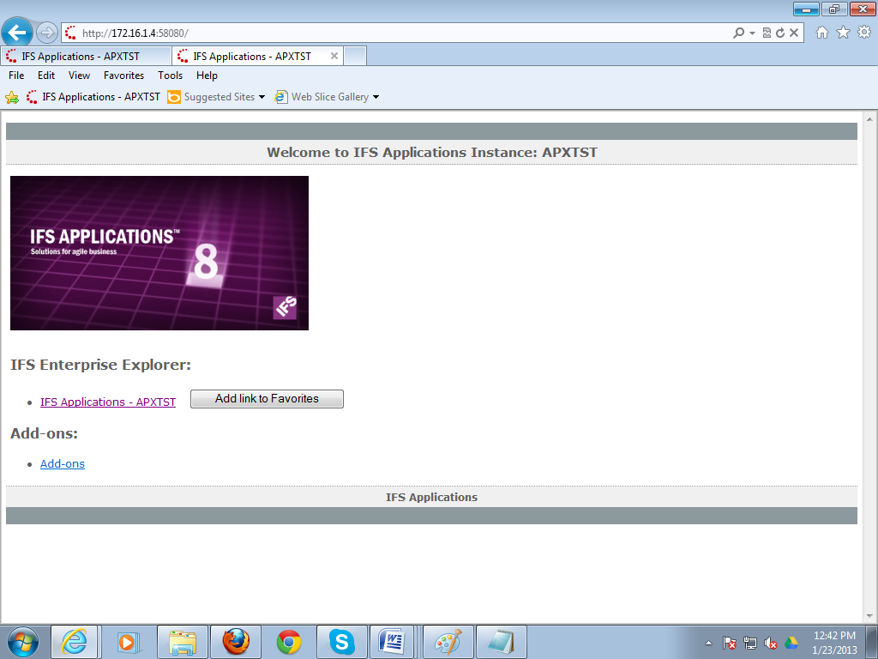
Window: Internet Explore
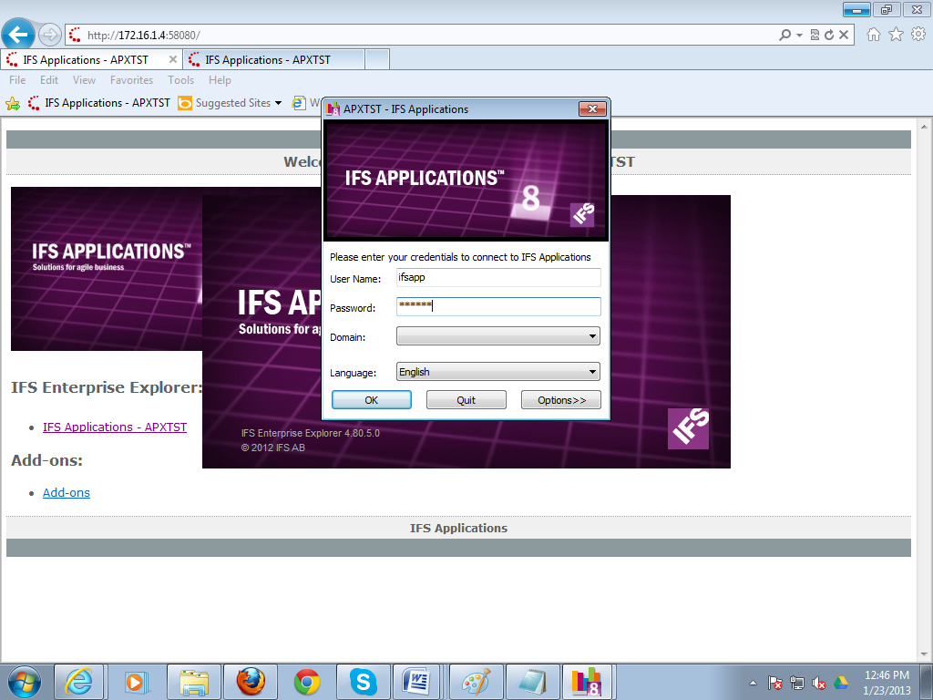
>>Enter User Name>>Enter Password>>Press OK

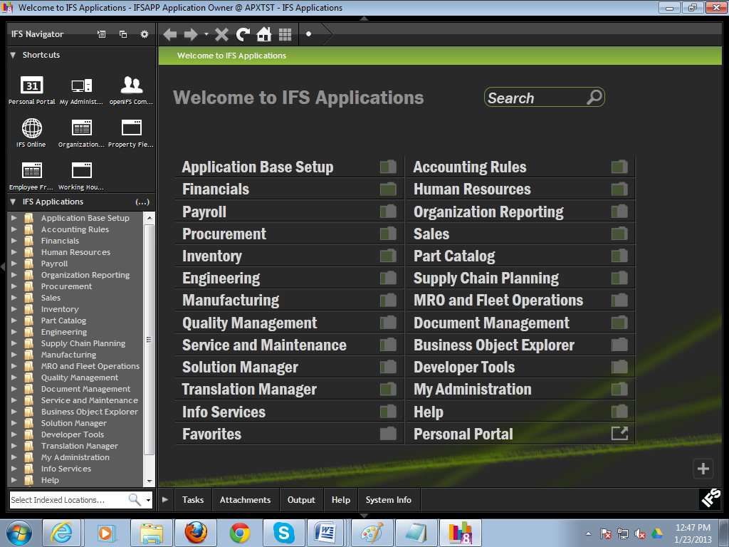

What are the shortcut keys of IFS?
Solution:
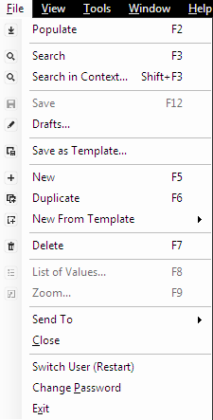

How to create a shortcut?
Solution:
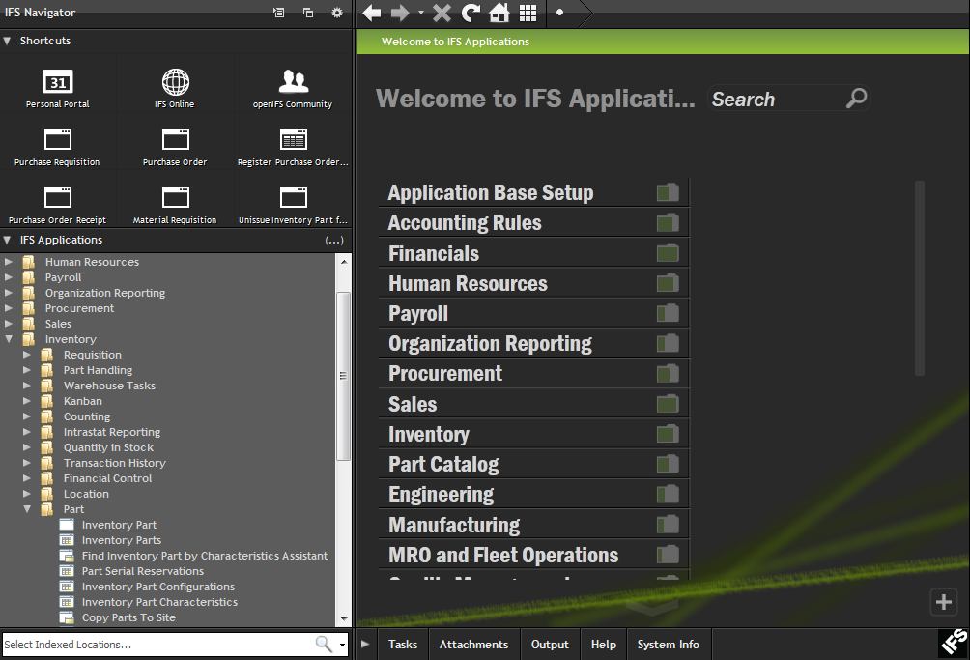
You can also enter a window by using shortcut key.
For creating shortcut key for a window, we just drag out the window from the navigation to shortcut frame.
How to open a new window?
Solution:
You can open a new window using navigator path. Suppose you want to open “leave Request By Administrator” window. Each window has a name. You can open this window using navigator,
Click on arrow sign>Sub Folder will open>>Click the name of window
Path: Human Resources\Leave Administration\Leave Request\Leave Request By Administrator

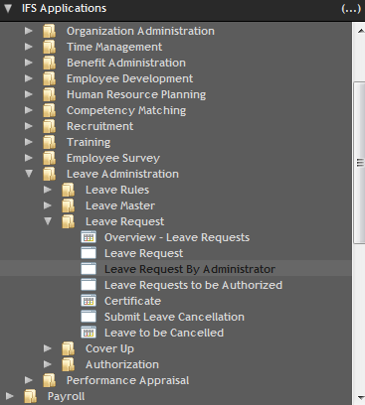
: How to search a new window?
Solution:
If you know the window name, you just write the name of window in the navigator text box.
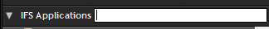
Then you will see the window in the tree menu.
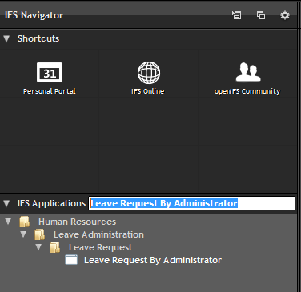
You can also type the window name like bellow
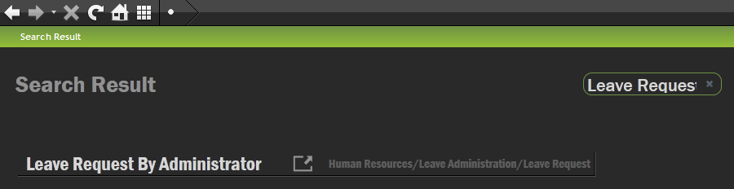

Introduction of Button:

Populate: Whatever the records are entered in this interface will be viewed by populate button.

Search: This button will be used for searching master records in that particular interface.


Save: Save all records in that interface.
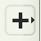
New: This button will be used to enter new data in that interface.

Duplicate: To copy existing record for editing to create a new record.

Delete: This button is used to delete a record.
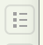
List of Value: This button can be used to search data for specific field (selected field) except master record data of that interface.

Zoom: This button can be used to create a new list of value data.
2) Inventory Part:
This interface is used for Creating part id (Unique Inventory Item) of any store related materials. For example 1) Raw Material 2) Finished Goods 3) Tools 4) Semi Finish Goods 5) Spare Parts etc.
Path: Inventory\Part\Inventory Part:
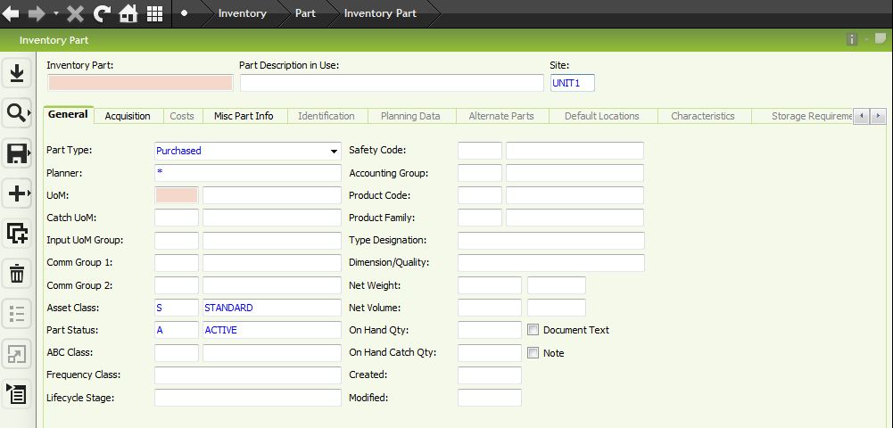

New Record: To enter new record click on new button
Inventory Part: Entry a unique part no (maximum 25 digits) of that particular item. We can use for inventory part only number (0-9), alphabet (a-z) and hyphen (-). e.g.: 01-CALF-BLK, 66-AMUN-ALTA, WE34-02205
Part Description in Use: Entry details of inventory part with in 200 characters. e.g: CALF LEATHER COLOR BLK, LAST AMUN-ALTA, SHOE ARTICLE WE34-02205
Site: Specific business unit (Unit1, Unit2, and ATL2). Select business unit from list of value (LOV)
Part Type: Select part type from combo list. For all raw material and tools select ‘Purchased Raw’ and for all finished and semi-finished goods select ‘Manufactured’
UoM (Unit of Measurement):Select unit of measurement from LOV. Put cursor of UoM field then click on LOV. New interface open with UoM value.
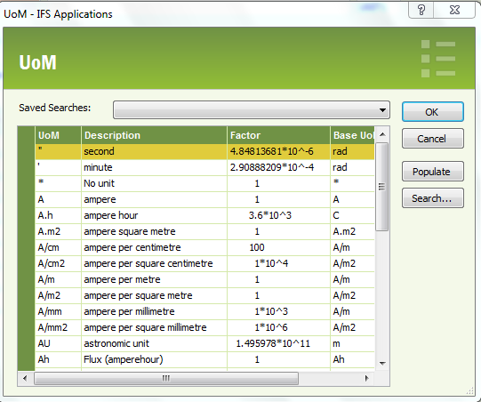
Click search button on this interface and will open new searching interface
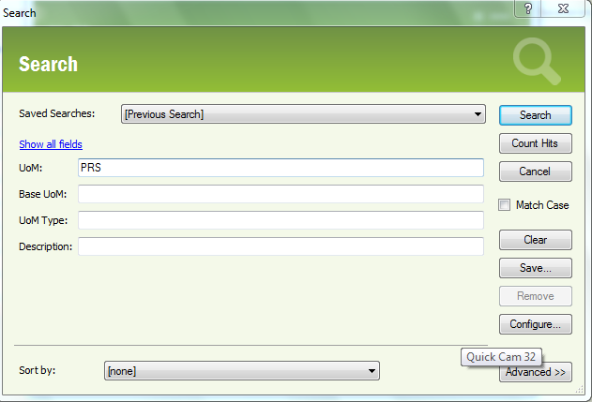
Put UOM on UOM field then click search button (User can also search any other field in that interface).
Searching item will open on below interface
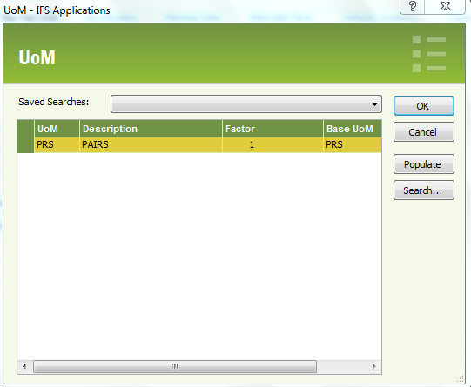

Select the specific UOM and click ok.
Accounting Group: Keeping cursor in accounting group field select from LOV. e.g. RM,FG,SFG,TOOLS,CONS.
Product Code:Keeping cursor in product code field select (Item 2nd category) from LOV.
Product Family:Keeping cursor in product family field select (Item 3rdcategory) from LOV.
Click save button, a new interface will appear.
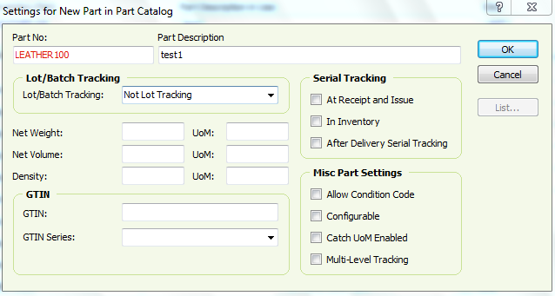
Lot/Batch Tracking: Select “Order Based” for FG and “Not Lot Tracking” for other accounting group.
Click Ok (Inventory part creation complete.)

Note: In case of tools (Non consumed): In inventory part interface keeping the cursor and right click and select “part”. New interface will come.
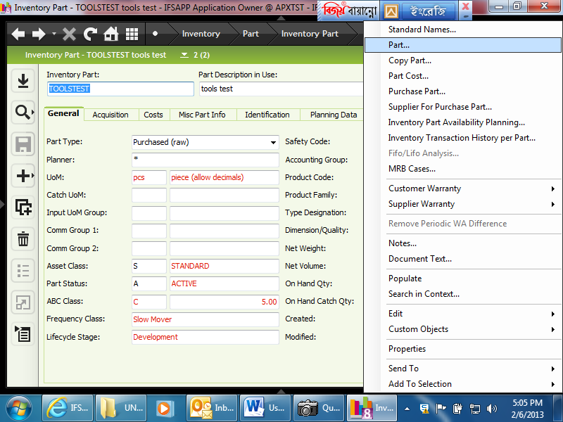

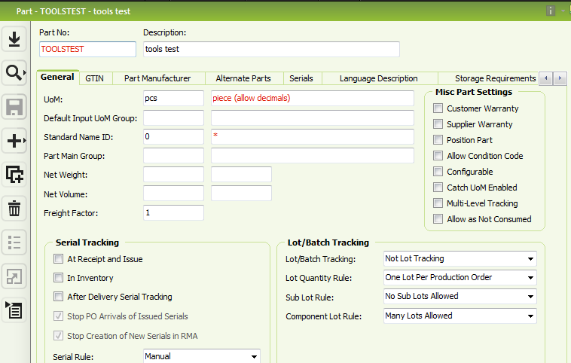
Select “Allow as Not Consumed” from Misc Part Settings check box. Then click on “Save” button.

3) Routing:
The set of operations which are required to complete the shop order(Bolla). e.g Cutting, Sewing, Lasting, Outsole, Insole etc.
Path: Engineering\Routing\Routing
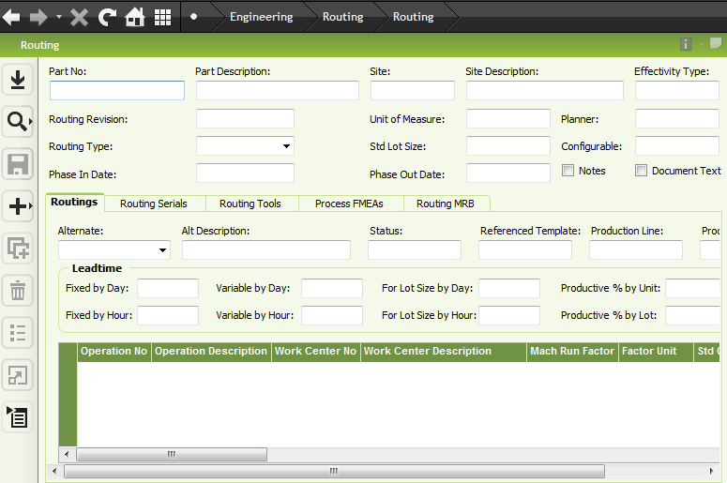
Keeping cursor in part no field click on search button and select the required manufactured part No (Article No)
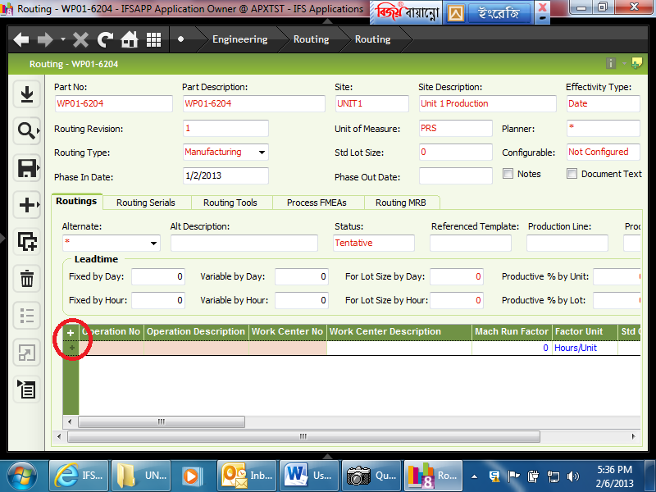
Operation No: Write operation no in details data entry table 1st column.
Operation Description: Write operation description in details data entry table 2nd column.
Work Center No: Put cursor in work center cell then select work center no from LOV.
Mach Run Factor: Productivity per hour of a particular operation against the work center Need manual entry.
Factor Unit: Select Factor Unit from list “Units/Hour” than Save.

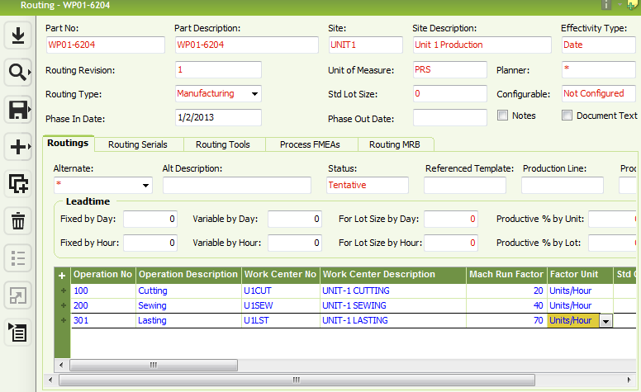
Note: In case of Outside work center (Moccasin) after save new windows will come.
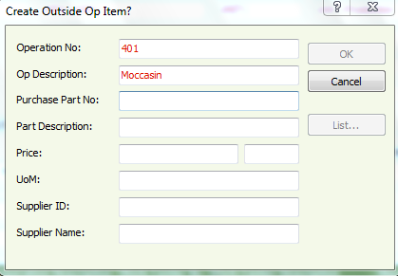
Purchase Part No: Enter purchase part no reference with Article and Job type. e.gWP01-6204-Moc
Part Description: Description of job type e.g. Moccasin stitching for article WP01-6204
Price:Per unit job work costing.
UoM: Select UoM from LOV.
Supplier Id: Select supplier Id from LOV.
Then click ok.
For completing the routing the status of the routing has to be changed from tentative to buildable.
For doing this: Keeping the cursor on the “Status” click right button and select Build.
If we don’t make the routing buildable we can’t use it in shop order execution.
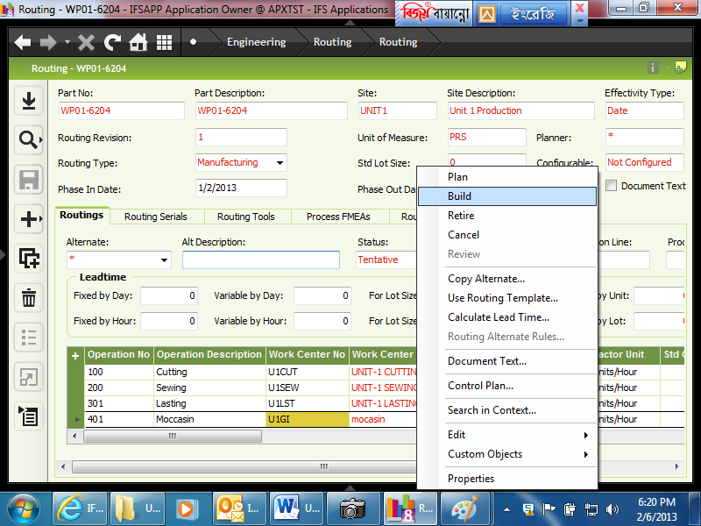

4) Routing Template
Path: Engineering\Routing\Routing Template
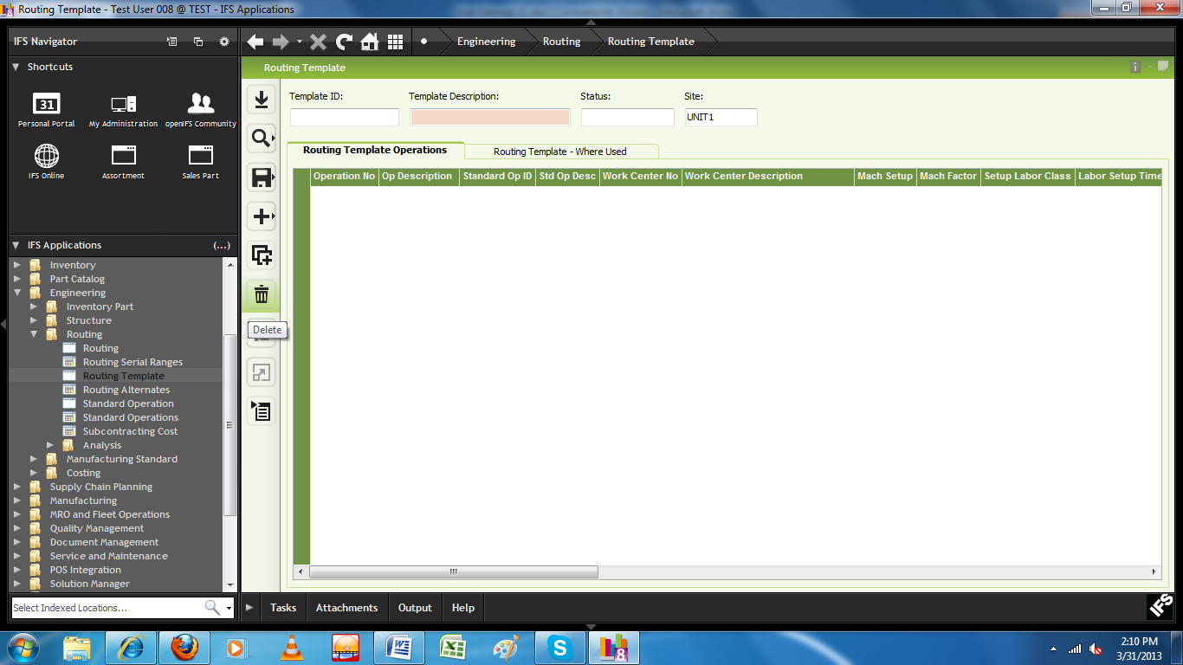
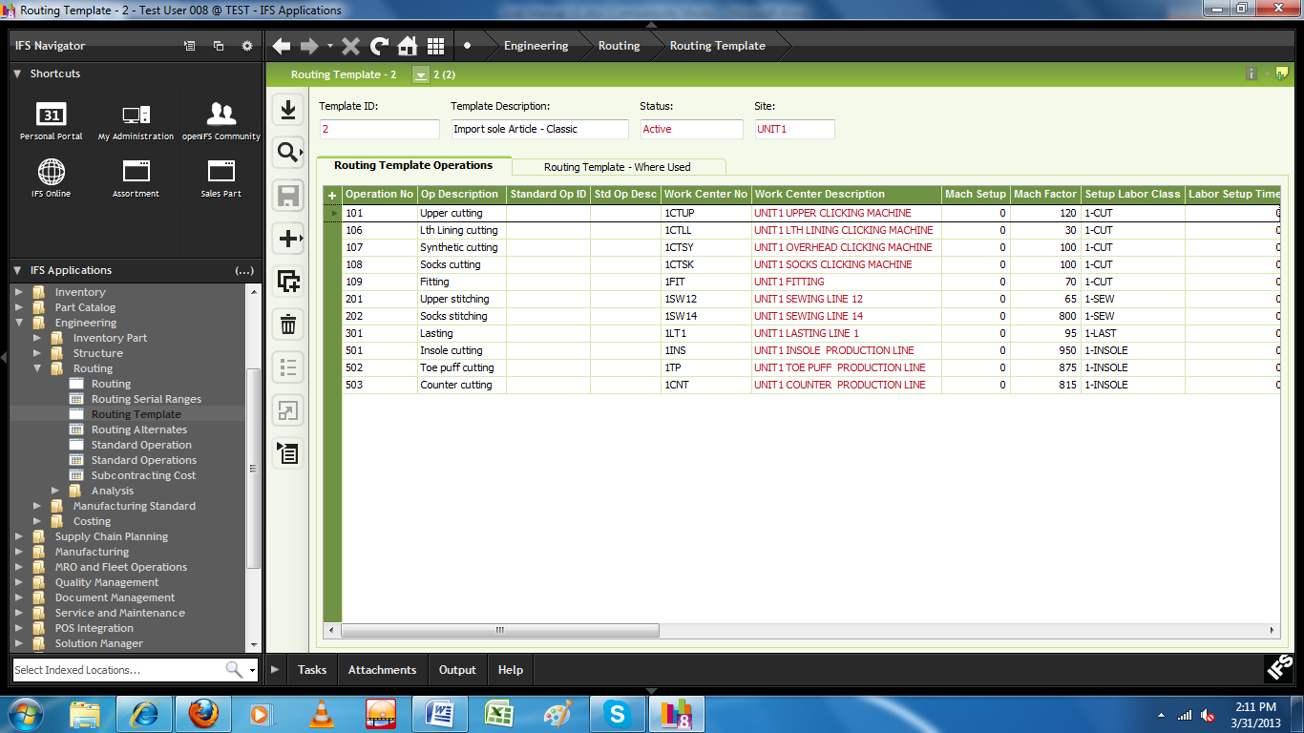

5) Using Routing Template
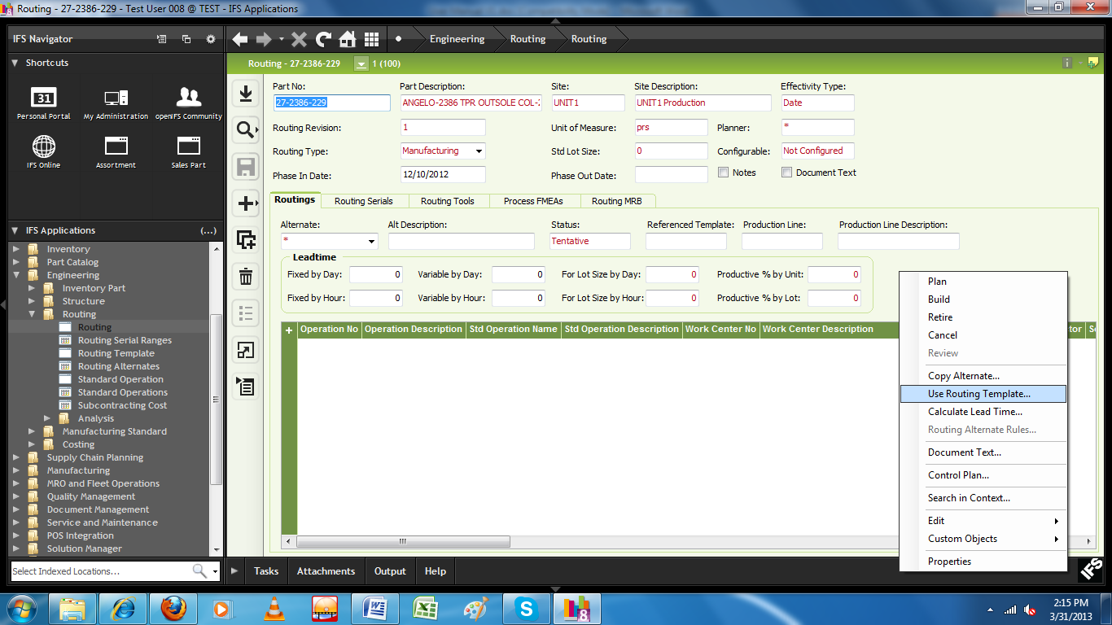
Select respective article against which routing definition is necessary .
Click RMB and select “Use Routing Template”
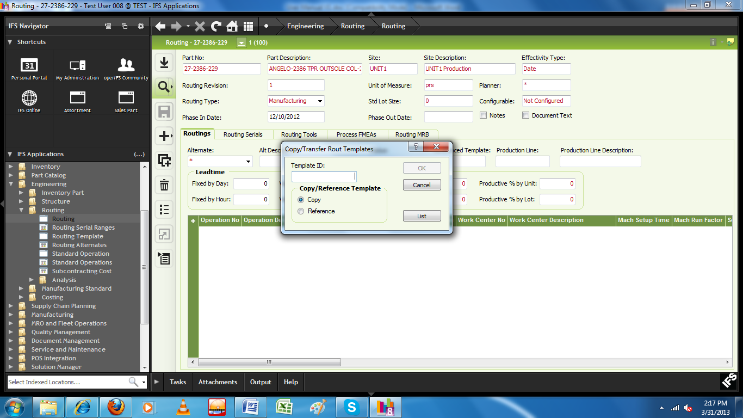
Select template ID from List and Select “Copy”

6) Product Structure:
Materials required for producing per unit of Manufacture item (FG-shoe, SFG-outsole) against each particular operation mention in routing will have to enter in this interface.
Path: Engineering\Structure\Product Structure
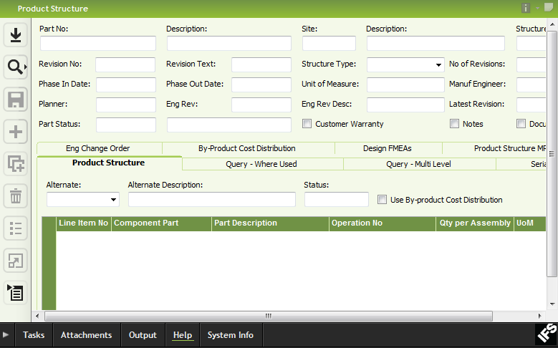
Keeping cursor in part no field click on search button and select the required manufactured part No (Article No)
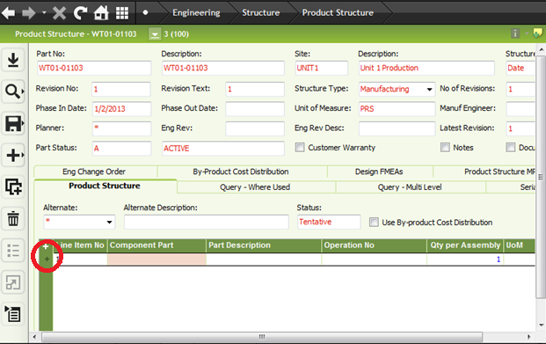
Line Item No: It’s a material sequence number eg 1,2,3…….
Component Part: Inventory Part No which we have created against the material required for producing this manufactured item.
Operation No: Operation no in which specific material will be used (Manual Entry).
Qty Per Assembly: Quantity of the material for producing one unit of manufactured item.
Consumption Item: In case of tool we have to choose “Not consumed” from the combo.
Click save button.
For completing the product structure the status has to be changed from tentative to buildable.
For doing this:
By keeping the cursor on the “Status” click right button and select Build.
If we don’t make the product structure buildable we can’t use it in shop order execution.

7) Sales Part
Path: Sales\Part\Sales Part
Objective of the sales part interface is to declare the manufactured item as sales part for sale purpose.
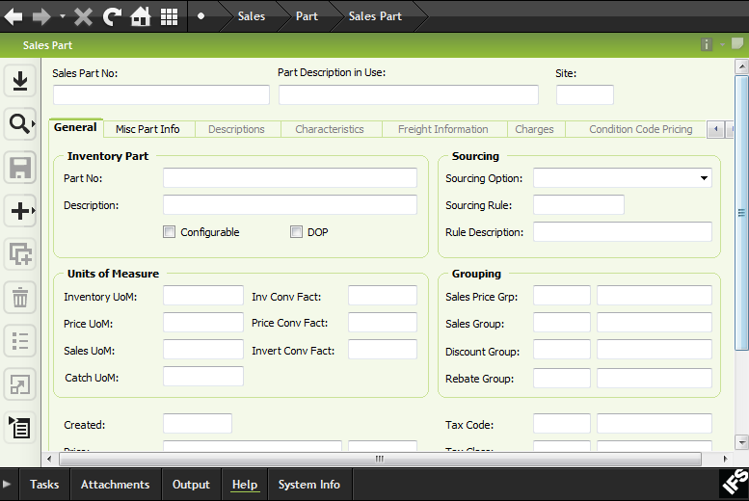
For creating a new sales part Click on “New Button”.
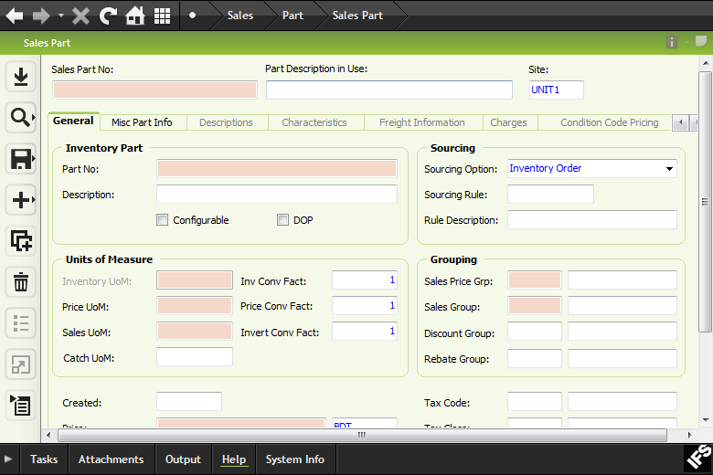
Part No: Keeping cursor in inventory “part no” field , click on search button and select the respective manufactured item which you want to declare as sales part.
Sales Part No: Then copy the inventory part and paste into “sales part no” field.
Sourcing Option: Select the sourcing option as “Order Based” from the combo.
Sales Price Grp: Select from the LOV.
Sales Group: Select from the LOV.
Tax Code: Select from LOV.
Price: Enter the per unit price.
Click Save Button.

8) Creating Customer
Path: Application Base Setup\Enterprise\Customer\Customer
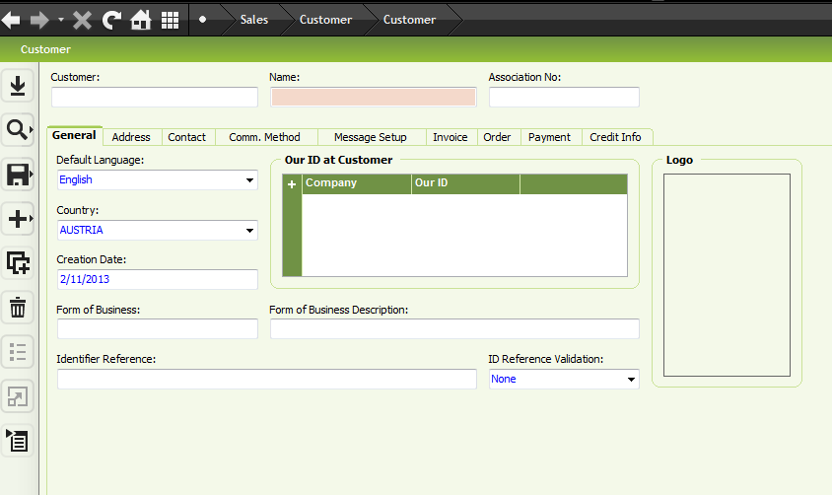
Create “+” new button to add new customer

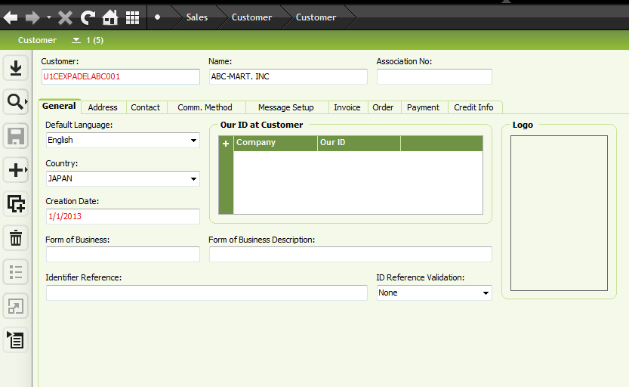

9) Customer Order
The objective of customer order is to enter all the information of an order (Bolla) i.e bolla no, deliver date, size wise quantity, customer information etc.
Path: Sales\Order\Customer Order
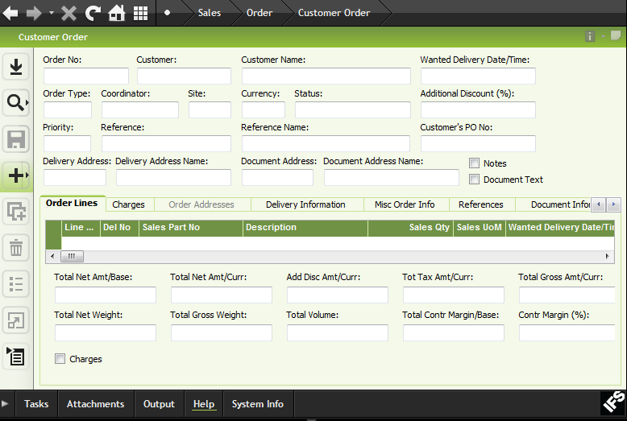
For creating a new customer order Click on “New Button”.
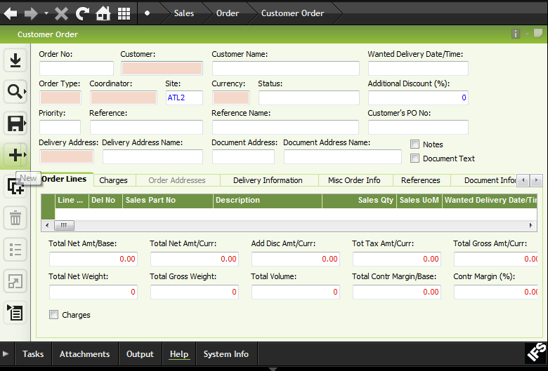
Order NO: Enter the Bolla no.
Customer: select customer from LOV
Wanted Delivery Date/Time: Enter customer date and time as 12PM
Coordinator: Select coordinator name from LOV
Click Save Button.
After saving Interface will give you the opportunity to add information.
Click “ +” button
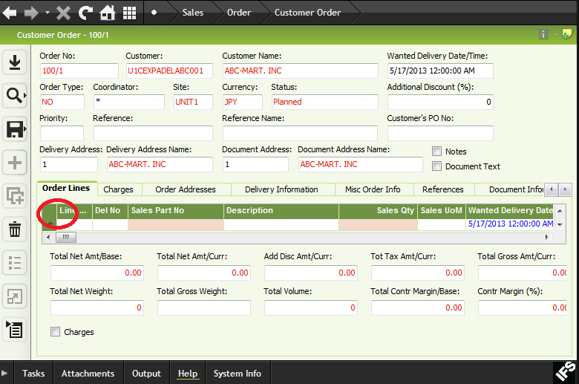

Sales Part No : Select from LOV
Sales Qty: Enter the sales quantity
Click Save Button.
Keeping cursor in the grid line, click RMB and select “Size wise Quantity”

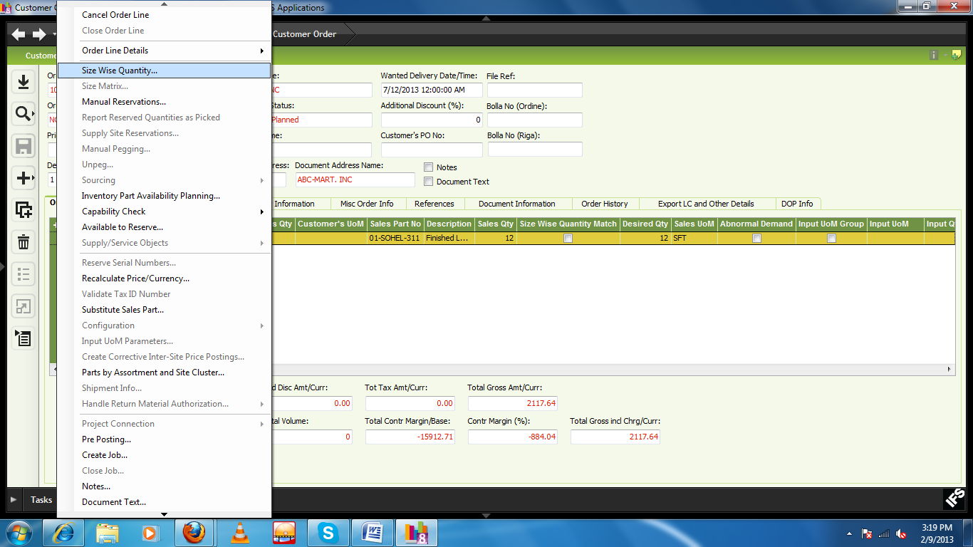
We have to enter shoe size and quantity manually.

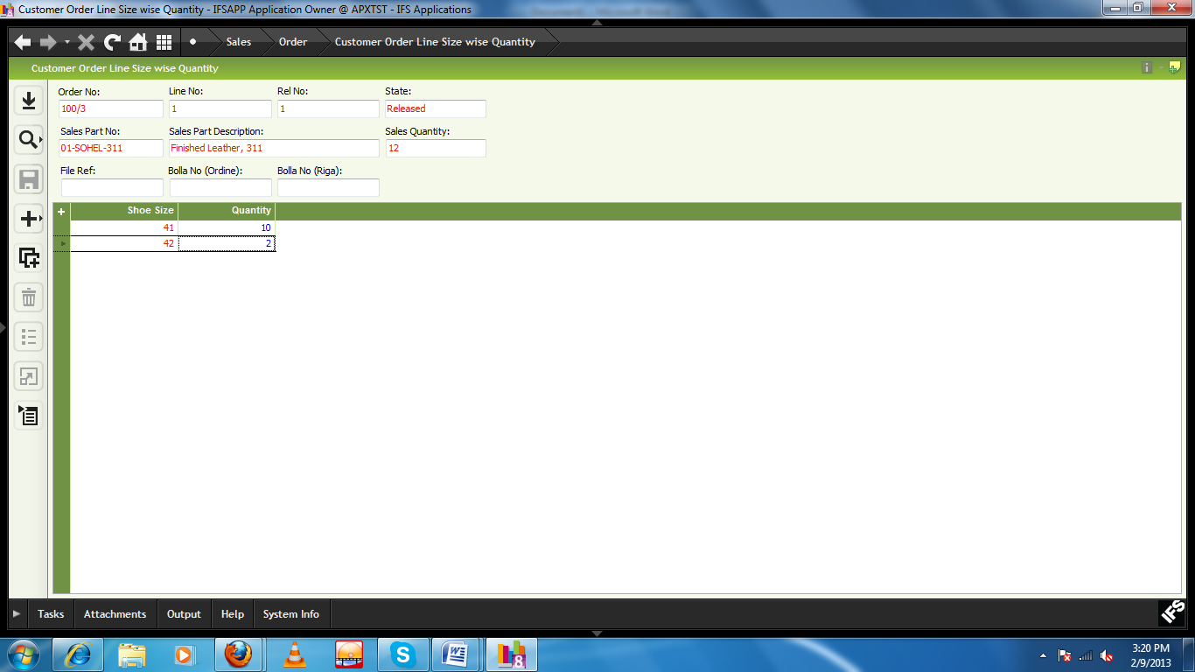
Click save button.
If the size wise entry is correct, system will show a Tick Mark in the “Size wise Quantity Match” column.
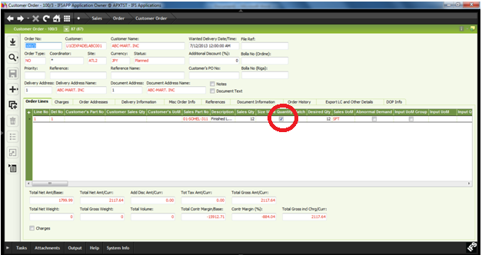

The customer order is now in Planned status.
For using the customer order as shop order we have to change the status from planned to Released.
For releasing the customer order Right click on “status” and click “Release”.

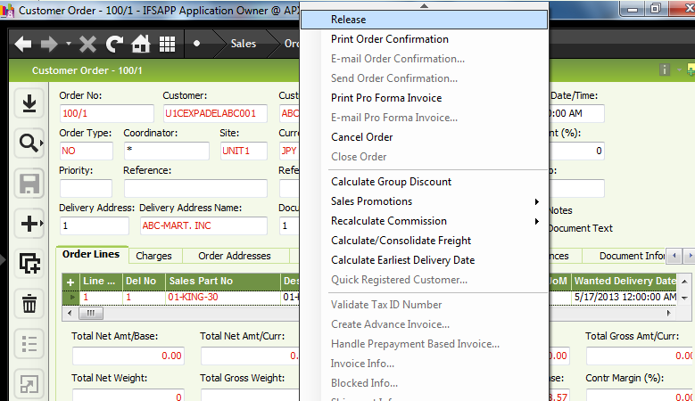
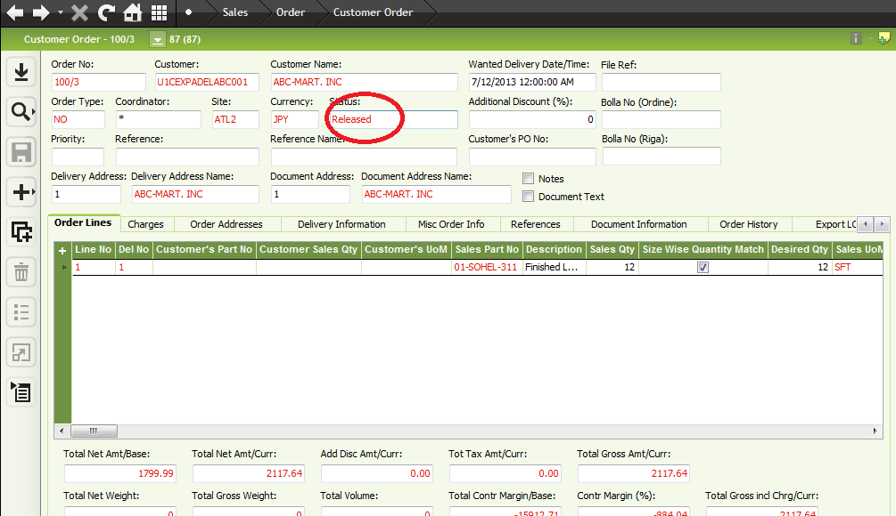
Now status is released.

10) Uploading List of Bollas

Preparing the file for migration

- Format of the text file should be as the attached file below.
(Double click on the file to open)

- Convert the “.txt” file to a “.csv” file.

- Open the text file using Microsoft Excel.
- Make sure each column in the text file is mapped in to a unique column in excel. (above file has 27 columns, so the excel file should also have 27 columns)
- Add a new column named “File No” as the first column.
- Replace the comma (,) with decimal point (.) in “Prezzo” column
- Remove Comma (,) from all the other columns
- Position of the columns of the file cannot change.
- There has to be a blank row between the column heading and the records
- Save the excel file as a CSV (Comma Separated Values) file.

Uploading the file to Incoming Customer Order

- Select “CUSTOMER_ORDER_MIG” job in Execute Job window.
- RMB in Detail Tab and select Load File.
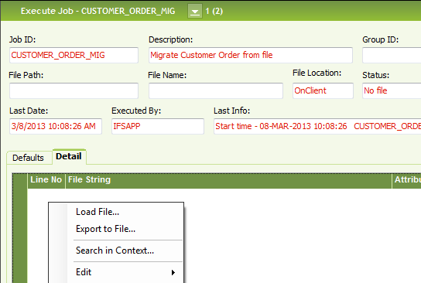

- Once the file is loaded, save the records.
- RMB on the header and select “Un-Pack file”
- If there are errors in the file they will be displayed under Error Message.

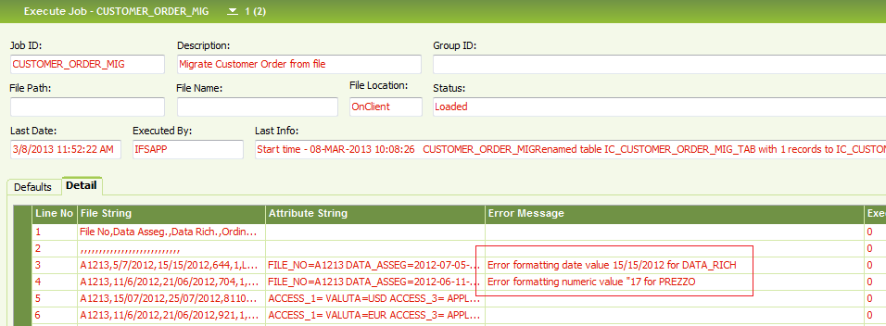

- RMB and select “Clean Up” to remove the file; do the corrections/remove the lines and reload.
- Once Un-Packed successfully, RMB and select “Start On line.
- A message will appear; select ok.
- Select “INCOMING_CUST_ORD” job in Execute Job window
- RMB and select “Start Online”.
- This will complete the data upload with a similar message as below. If there are errors it will show under Error Messages.

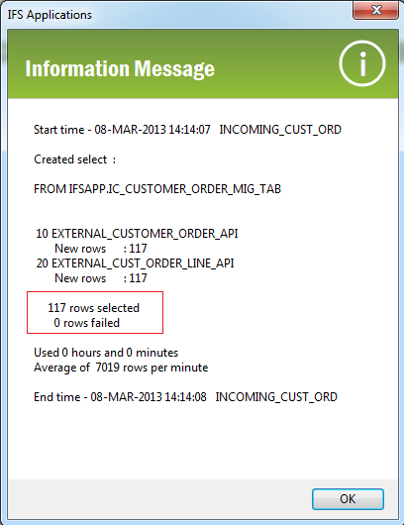

Bollas are uploaded in to Incoming Customer Orders in IFS.
Sales\Order\Incoming Messages\Incoming Customer Orders

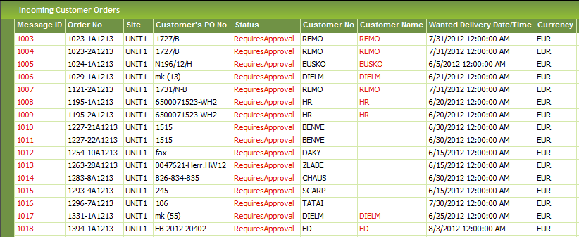

Sales\Order\Incoming Messages\Incoming Customer Order

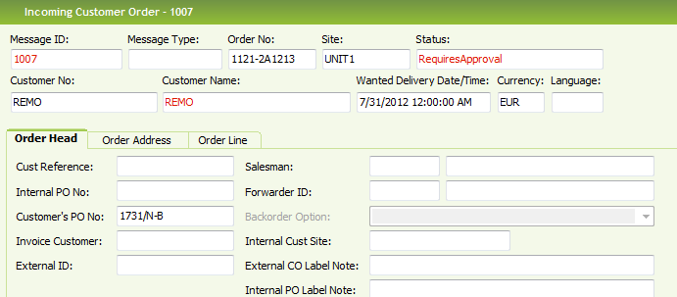

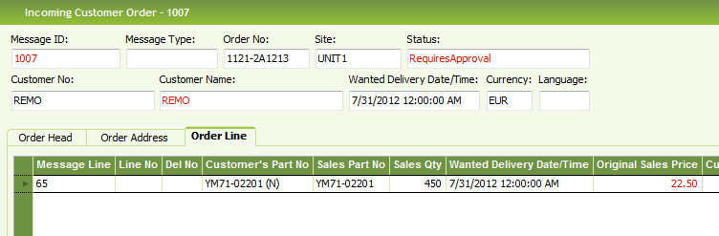

Creating Customer Order from Incoming customer Order

- Select a line or multiple lines in “Incoming Customer Orders” and select Approve.
- Status will change to Created or Stopped.
- Created - successfully converted into a customer order
Stopped - something went wrong with the conversion and that it needs to be corrected or canceled.

- Errors will be displayed under error Message; you need to do the corrections accordingly and approve again.

11) Parallel Operation and Milestone Operation
Parallel Operation declaration in Routing is very essential for the proper scheduling of the shop orders.
We have confirmed and finalized a fixed operation sequence for the proper and authentic scheduling purpose. The sequence of the operation is given in the below window :-
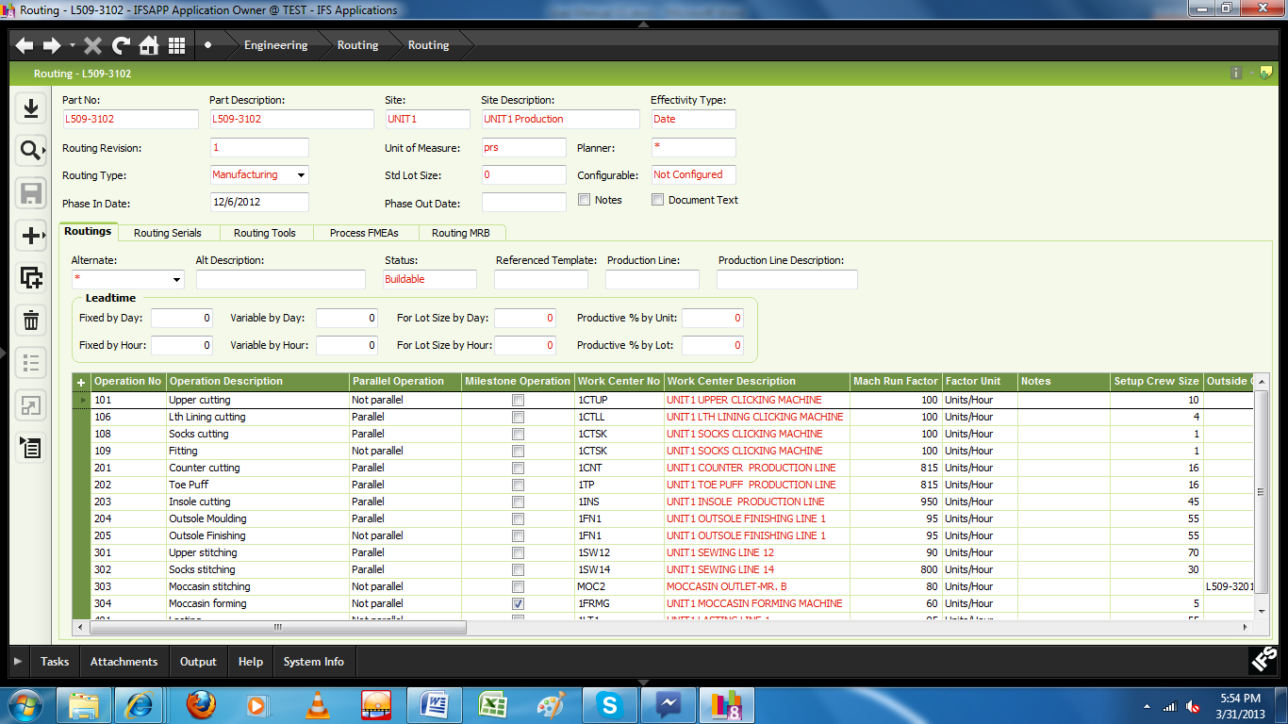
When we mention an operation as milestone, we can’t report more than the equivalent gross quantity of the milestone operation in the next operation reporting.

Shop Order
The objective of shop order is to specify/inform the system the confirmed materials and routing against a particular order/bolla. Actually shop order is the heart of IFS system because we have to use shop order window for material issue, production reporting, re cutting, quality reporting and also receiving the FG in inventory.
Path: Manufacturing\Shop Order\Order\Shop Order
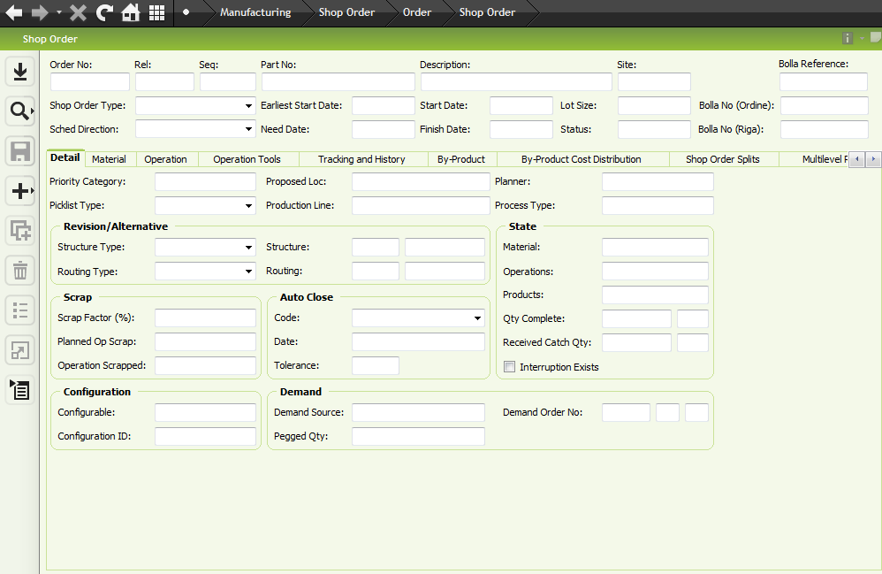

Order No: Keeping cursor in “Order no” field , click on search button and select the respective order no (bolla no).
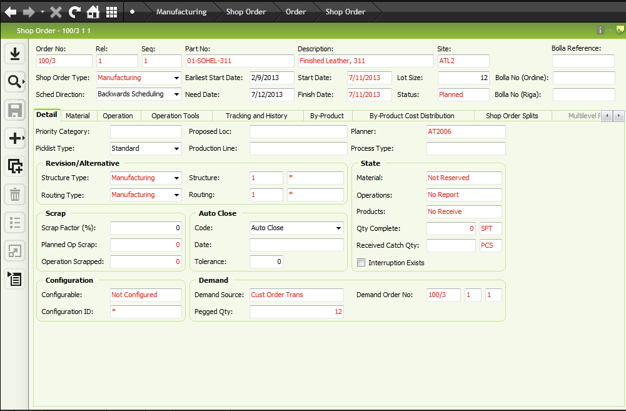
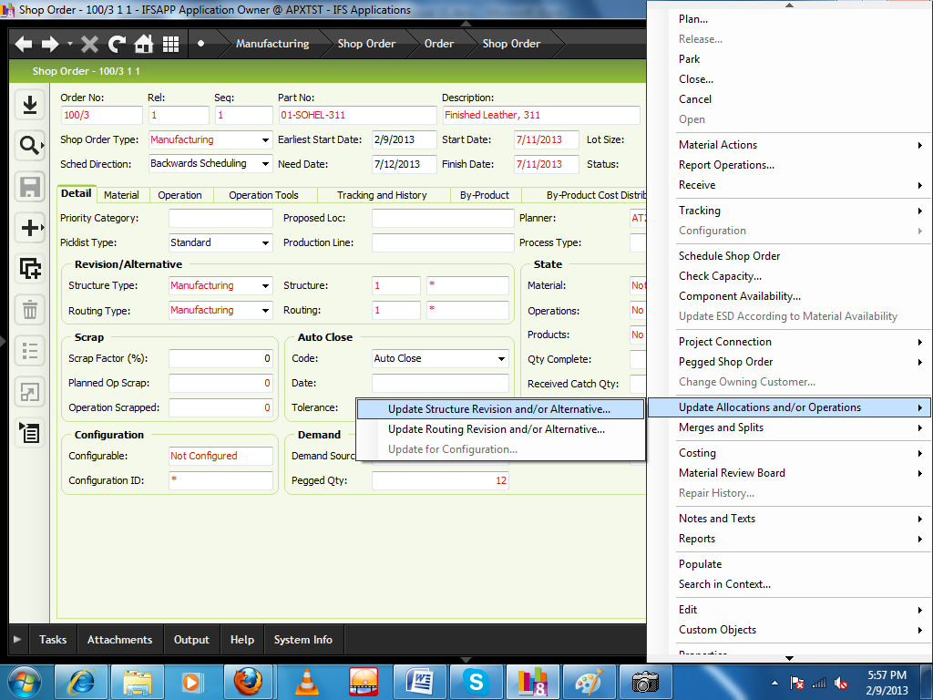
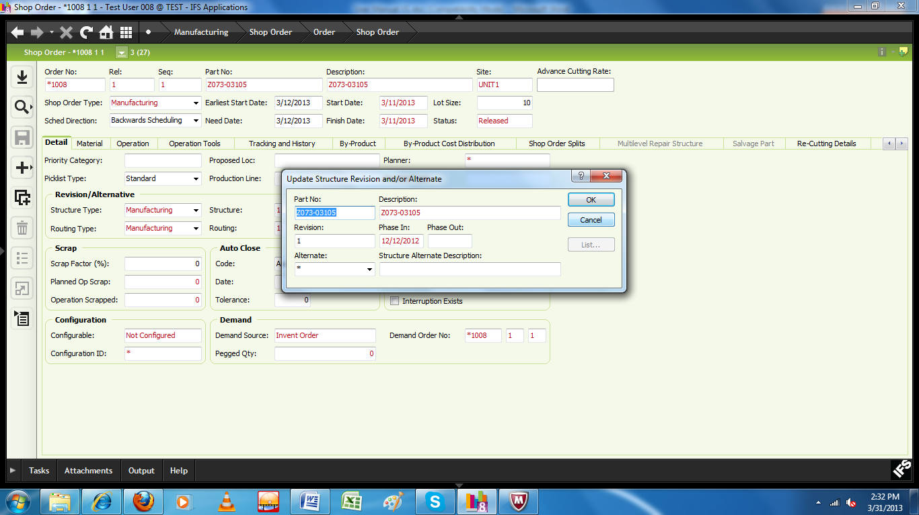
Select the Alternate option from the combo.
Click on Material Tab
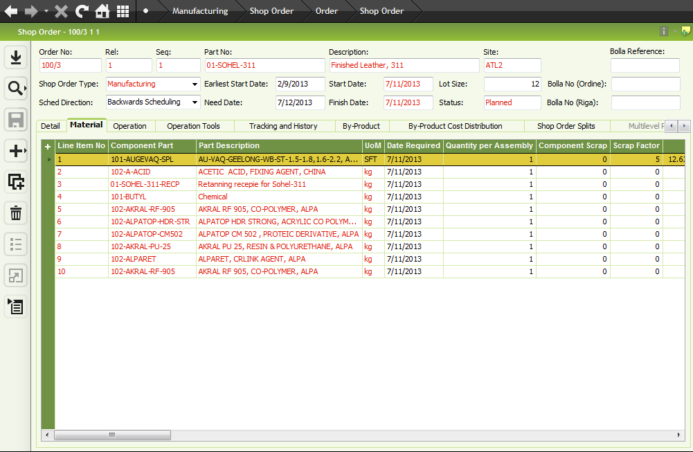
If needed we can change, add or deduct material (component part) and quantity (quantity per assembly) from the screen as per shop order (bolla).
Note: For using Alternate or Revision of Product structure of an article we can use the following the system. Right click on shop order user screen and go to Update Location and /or Operations and then go to Update Structure Revision and /or Alternative.
Same as for routing (Update Routing Revision and /or Alternative).
Click on Operation Tab
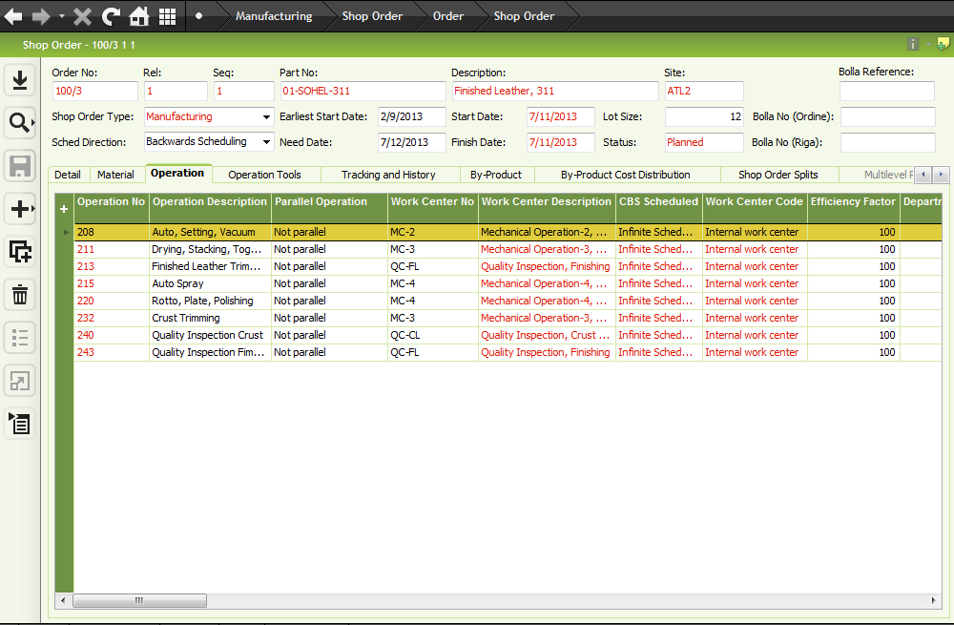
If need be - we can change the work center (work center no) and per hour productivity (machine run factor) as per production planning.
Shop order is now in “Planned” status.
MRP
Path: Supply Chain Planning\Material Requirements Planning\Batch Job\Perform Site MRP
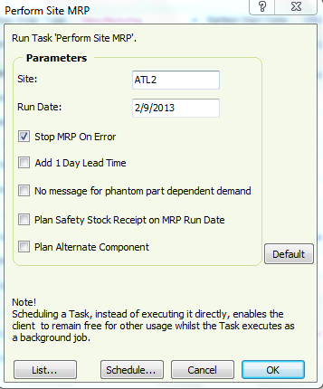
Click OK button to execute the MRP process.
/*

13) Purchase requisition

14) Purchase order

15) Material receive

*/

To execute the shop order we need to change the status from planned to Released.
For releasing Click RMB on “status” and Click “Release”.
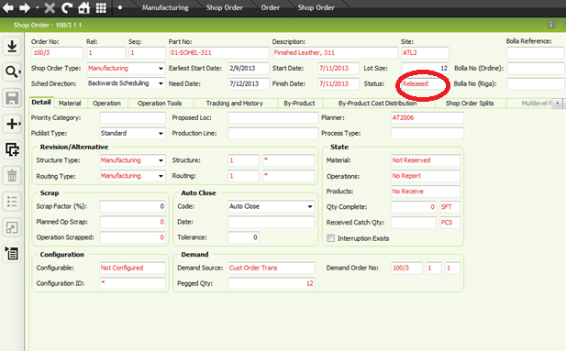

16) Material Availability Check against shop order.
Path: Financials\Report Generator\Order Report
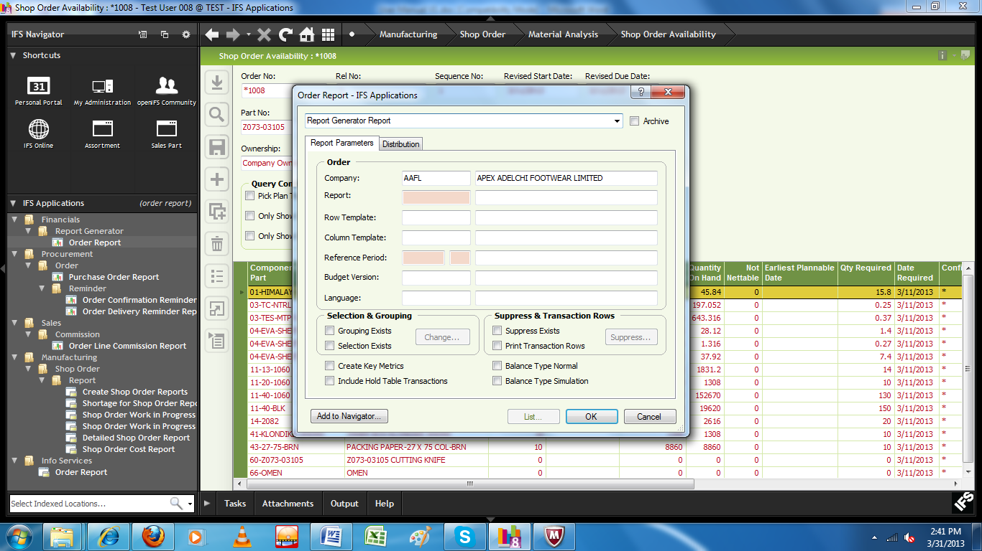
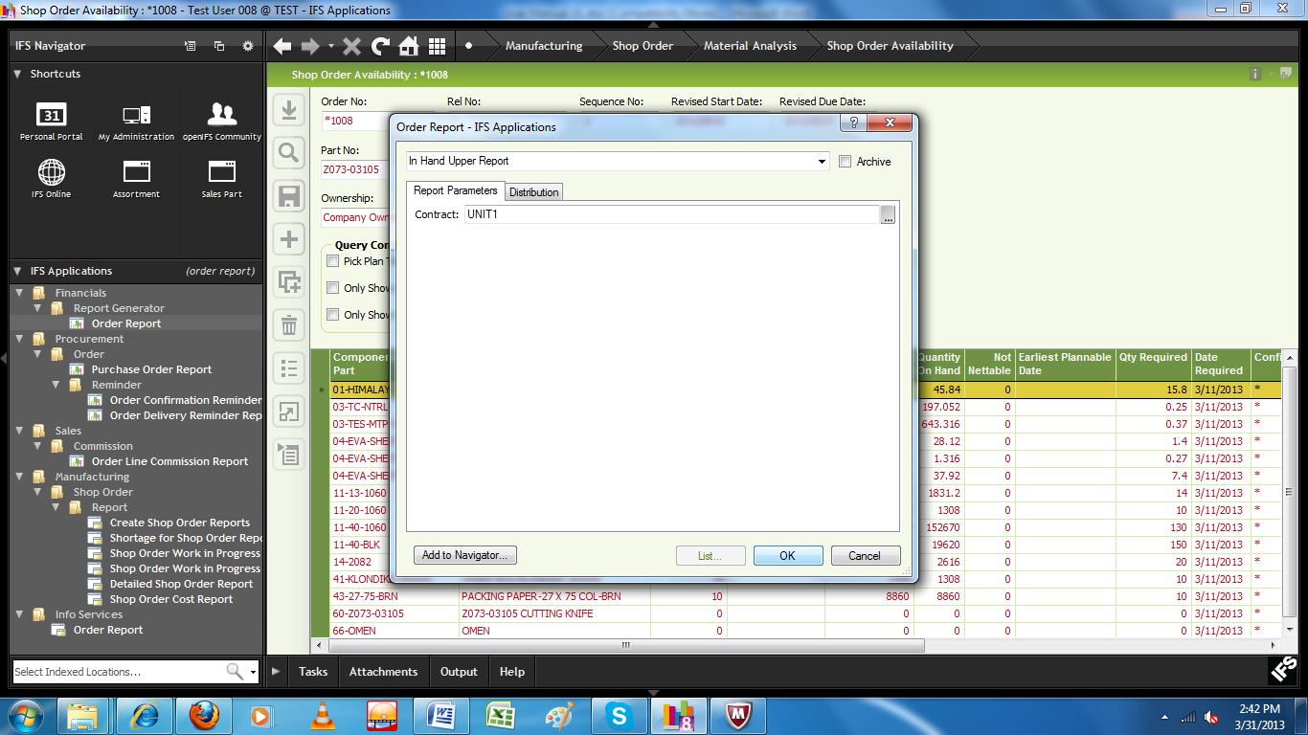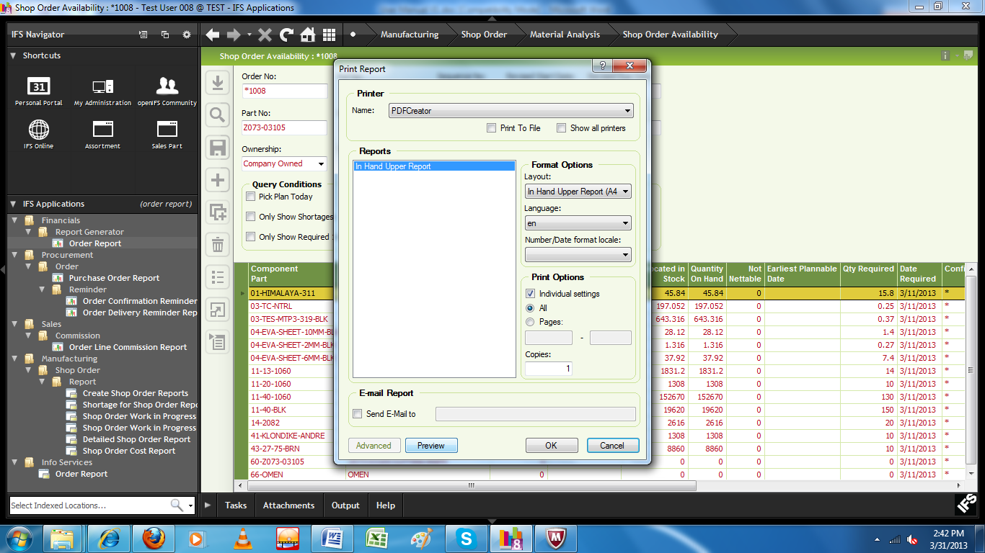
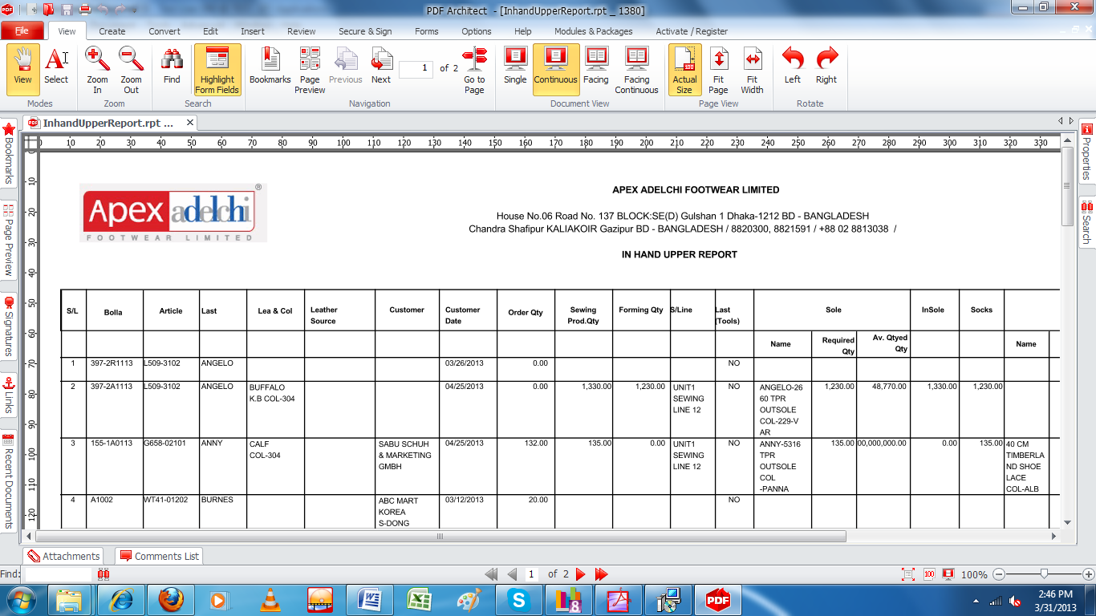

17) Checking of total stock of a particular article

Right click on shop order user screen and go to Component availability Check.
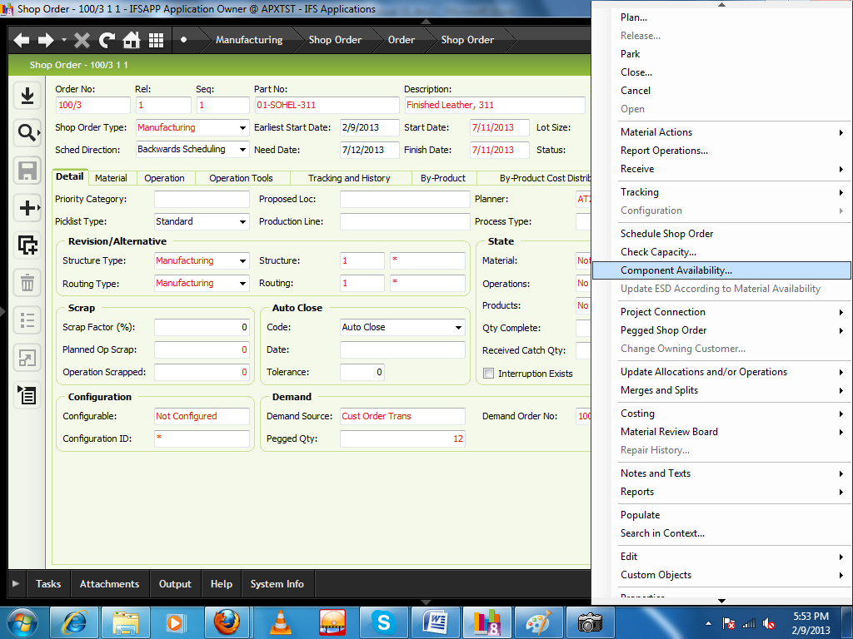
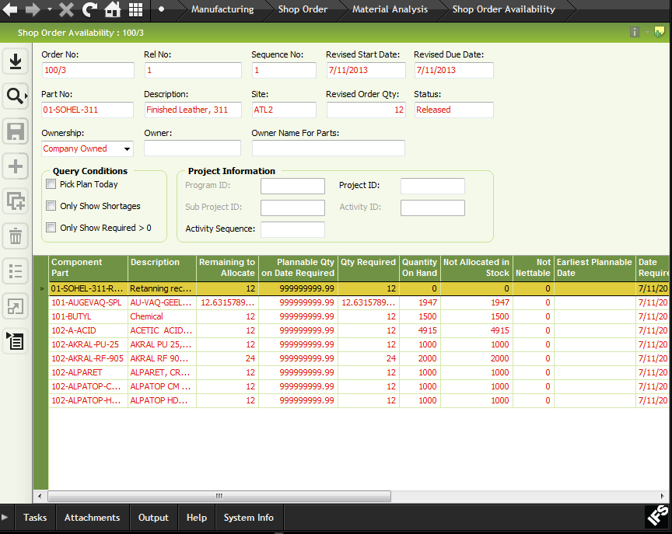

Miscellaneous Material details in Shop Order

Design

- New Tab is introduced to the Shop Order as “Misc. Material Details.
- This tab is editable until the Shop Order reaches status Closed.
- Lines can be manually selected from LOV as well as selected from a template defined under Part Catalog\Characteristic\Part Characteristic Template.
- LOV for the “Code” is from Part Catalog\Characteristic\Part Characteristic-Variable characteristics.
- Status and Sourcing columns have Drop Down selection options.

Manually entering lines

Create a new Line

Select the “Code” from LOV

Select the Status from drop down

Select the Sourcing from drop down

Enter Notes (Optional)

Save

Using a Template

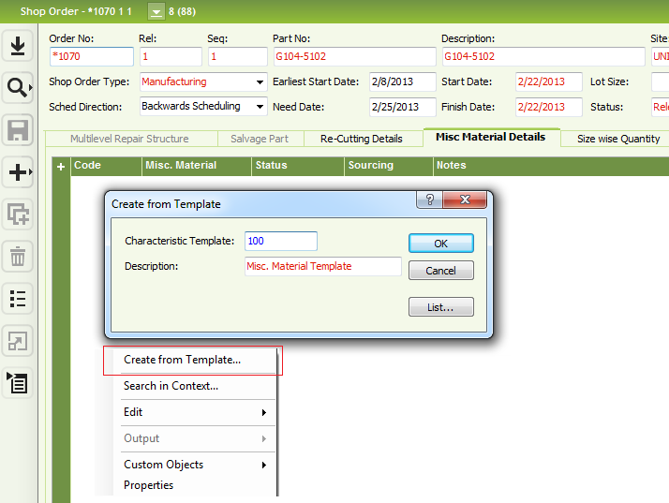

RMB and select “Create from Template”

Select the Template in “Create from Template” dialog.

Select the Status from drop down

Select the Sourcing from drop down

Enter Notes (Optional)

Save

Defining Basic Data

Part Catalog\Characteristic\Part Characteristic-Variable characteristics.
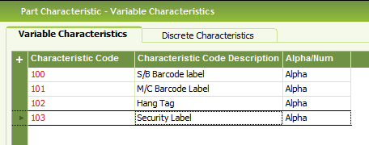

Defining template

Part Catalog\Characteristic\Part Characteristic Template
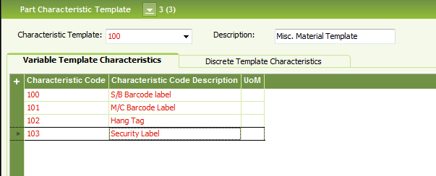

Advance Cutting Rate in Shop Order

Consider the following Shop Order which has been created from a Customer Order.
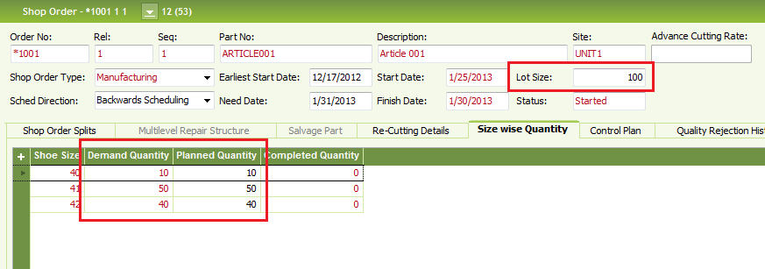

Demand Quantity is coming from the Size Wise quantity entered in Customer Order.
Planned Quantity is initially comes same as the Demand Quantity.

Enter Advance Cutting Rate

RMB in Shop Order Header and select “Apply Advance Cutting Rate”
Enter the rate in the pop-up window. There will be a confirmation message.
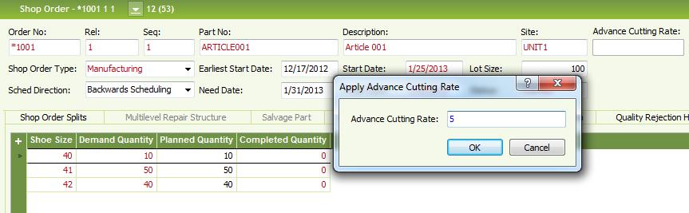
There can be different standard Information messages or error messages which apply to changing the Lot Size of the Shop Order.

If there are no errors, Lot Size of the Shop Order and Size wise planned Quantity will be updated.

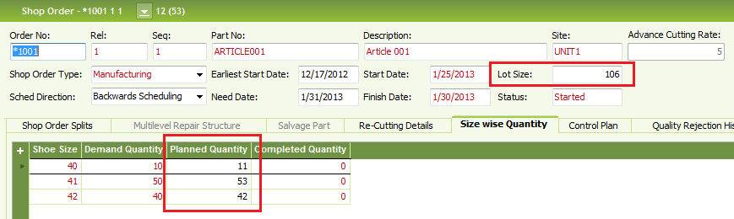

Method 2
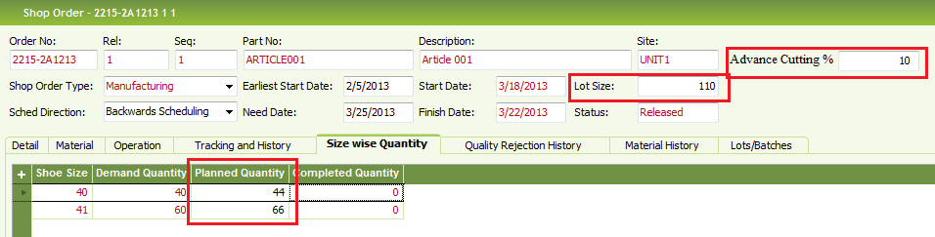

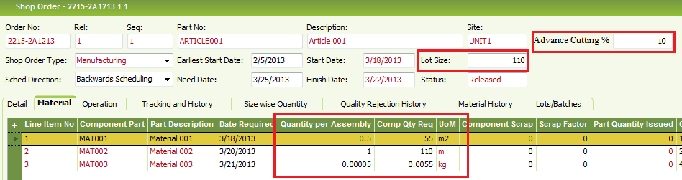
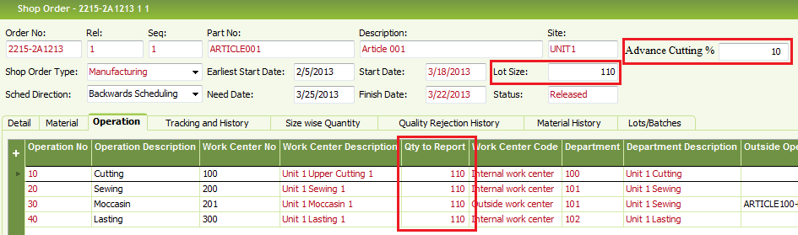
- Advance-cutting % is entered in the Sop Order header.
- Size wise quantity is re-calculated according to the Advance-cutting %, under Planned Quantity column.
- Sum of the Planned quantity will update the “Lot Size” in Shop Order header.
- OriginalBolla Quantity. Can be seen under “Pegged Quantity” in Shop Order Detail Tab.
- Advance-cutting % will re-calculatethe material requirement and quantity to produce against each operation according to new Lot Size..
- Shop Order will remain open until you receive the Finished Product (Article) to inventory up to “Lot Size”; you may manually close an open Shop Order.
- Semi Finished Goods (Out Sole), and Raw materials are planned based on the “Lot Size” , that will be including Advance-cutting %.

20) Shop Order Material Request (SOMR)
Shop Order Material Request-User Guide

- Shop Order Material Request (SOMR) is used to request materials from stores for a Shop Order based on different criteria’s.
- Materials can be issued to the Shop Order through the same SOMR.

Process of using SOMR is explained using the following Shop Order as an example.

Shop Order Material Lines
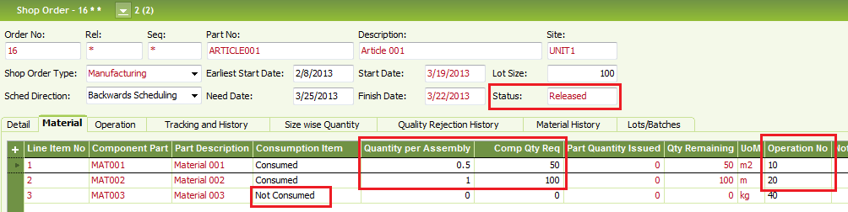

Shop Order Operations
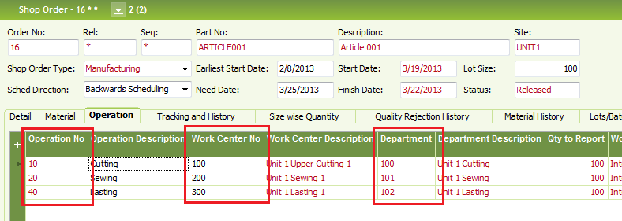
Work Center Settings for Production Line and Department
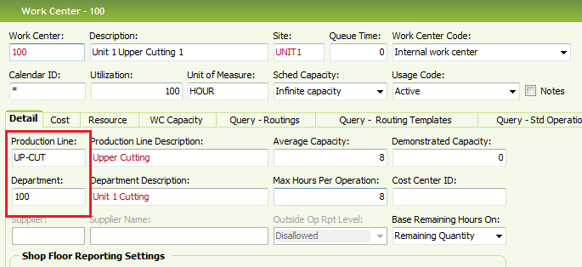

Create SOMR

RMB on the header of Shop Order and select “Create Material Request..”. Shop Order must be in Planned, Released, or Started status.
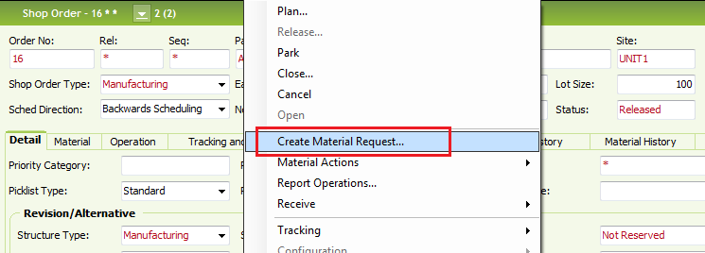

SOMR window will open with header information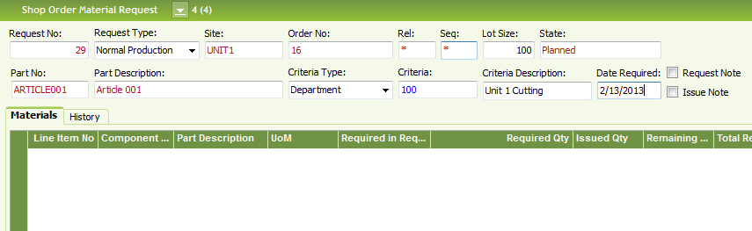

- You may select Request Type Normal Production or Re-Cutting
- Enter the required date of materials under Date Required.
- Lot Size is the planned production quantity. (eg. If Lot Size is changed to 10, material requirement will be calculated for 10 pairs of shoes)
- Criteria Type is optional. You may select Department, Production Line, Work Center or Operation and select the criteria from LOV.
- If criteria is selected, material lines will be created for that criteria. For example if you select Criteria type as Department and select Department ID 100 for Criteria, only the material lines which are connected with operations having Work Centers, connected with Department 100 will appear in the request.
- After saving the header, RMB and select “Create Material Lines..”
- Material Lines will be created according to the selected criteria for materials where Consumption Item is set to Consumed in Shop Order.
- After creating the lines you may only change Request Type and Date Required. You may add free notes using “Request Note” RMB option.
- Select “Required in Request” check box to include the material line in the SOMR. Un-selected lines will be deleted when the SOMR is released.
- You can manually change the “Required Qty” in material lines.
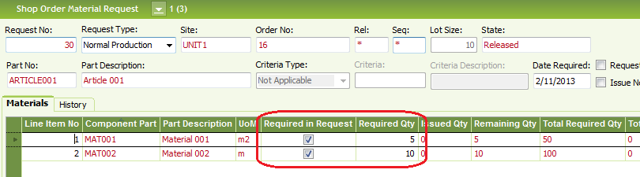
- RMB and select “Release” to change the status to Released. Un-Selected lines will be deleted.
- Material lines cannot be modified after release but you may still add “Request Remarks” in material lines.
Without Criteria
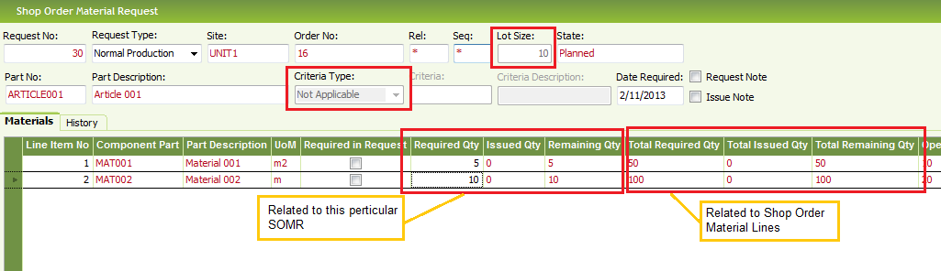
Required Qty =(Quantity per Assembly * Lot Size) / (1 - (Scrap Factor / 100))

With Criteria (Department 100)

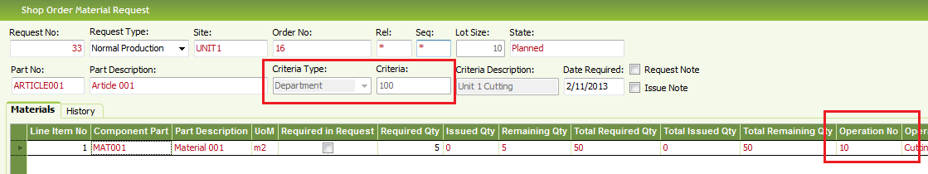
Only the material connected with Operation No 10 is in the SOMR.

Issue material to Shop Order through SOMR

Select a material line and select “Manual Issue”. You will be directed to the “Manual Issue Shop Order window”. This is same as using manual issue option in a Shop Order; in addition to the standard issue window you will see the SOMR information in the issue window.

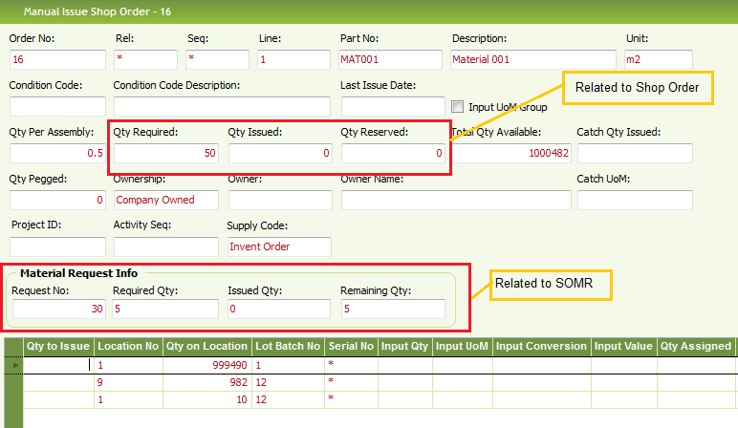

- Enter “Qty to Issue” and save. This will issue materials to the Shop Order.
- SOMR No will be written to the Note field of transaction history against the material issue transaction.
- Depending on the status of issuing materials, status of the SOMR will change to Partially Issued or Issued.
- You may add Issue notes in the header or Issue Remarks for Material Lines in the SOMR.
- You can close the SOMR by using Close RMB option. Materials cannot be issued in Closed status.
- If you want to further issue materials against the same SOMR, it can be re-opened using “Re-Open” RMB option.

Un-Issue Materials

Un-issuing of Shop Order Materials is done through the standard un-issue process. There are no changes to this process.
The only addition is, in the “Manual Unissue Shop Order” window SOMR No is displayed under “Source” column.
So the user can select un-issue is done against which SOMR.
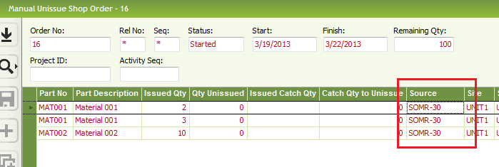

- If the SOMR is in Closed Status it needs to be Re-Opened before un-issue is performed.
- Once un-issued status of the SOMR, Issued Qty and Remaining Qty of material line will get updated accordingly.
- SOMR No will be written to the Note field of the Material Transaction History against the Un-issue transaction.

SOMR Status Change

Delete
SOMR is deleted from the system
Planned

Release
Cancelled
Cancel
Released

Un-Issue Materials
QtyIssued of all line is =0

Issue Materials
Qty Remaining of at least one line is > 0

Partially Issued

Un Issue Materials
Qty Remaining of at least one line is > 0

Completely Issue Materials
Qty Remaining of all lines is zero

Close
Issued

Re-Open
Close
Re-Open
Closed

Status History

History of the SOMR can be tracked in the History tab.
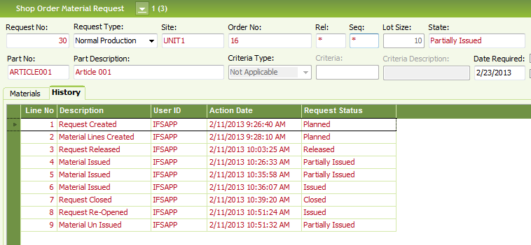

24) Manual Issue

Click RMB on Shop order respective material gird (row) and click “Manual Issue”.
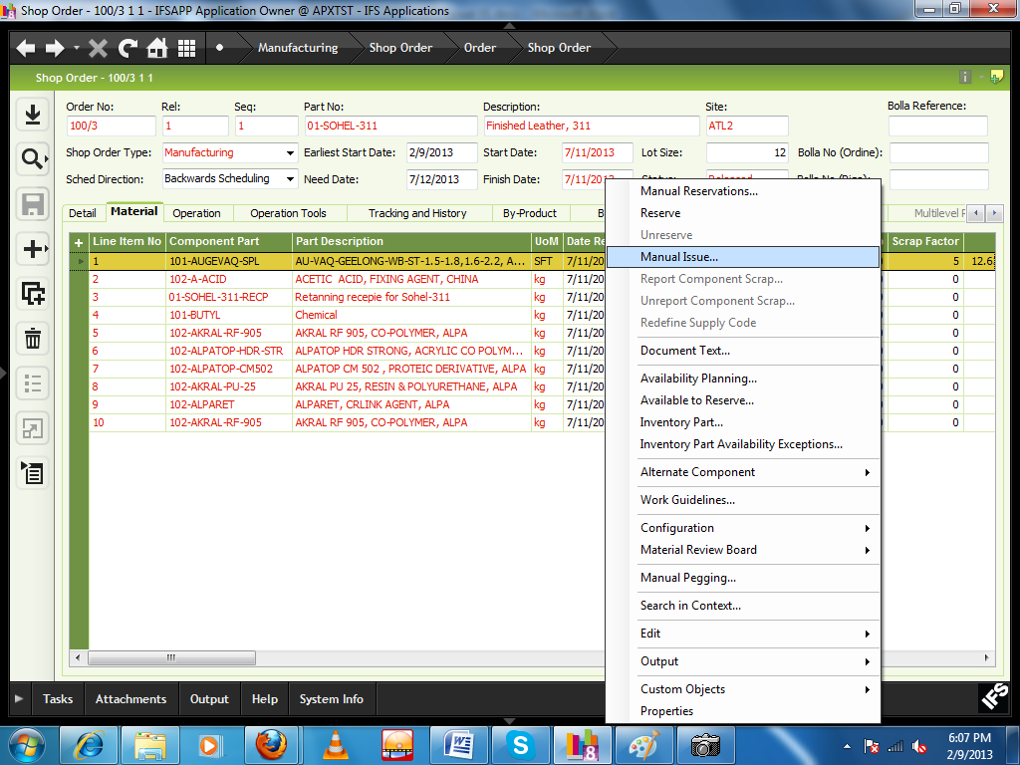
New Interface will come
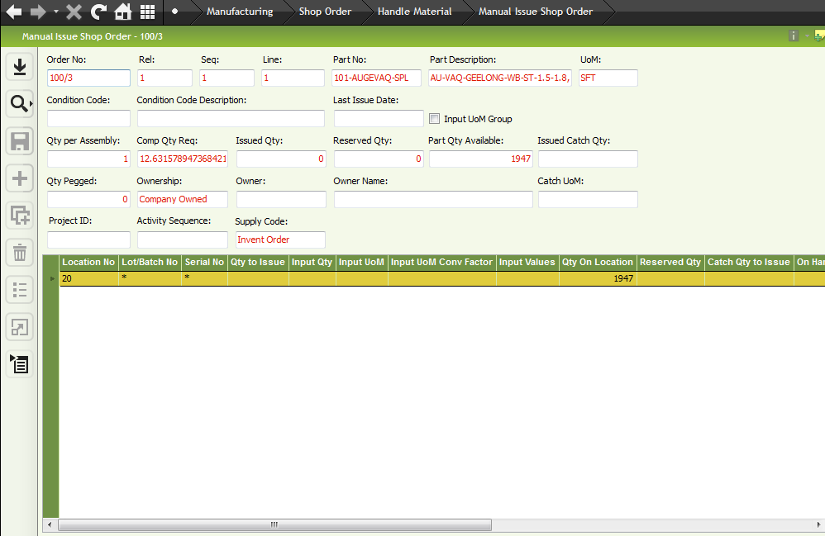
Enter component required quantity to “Qty to Issue” field.
Click Save button.
When all the material will be issued according to the required quantity the state of material will be changed to “completely issued”

25) Material Unissue (Floor Return)

Shop order should be in “Detail tab” phase
Click RMB and select “Material Actions” then click “Manual Unissue”

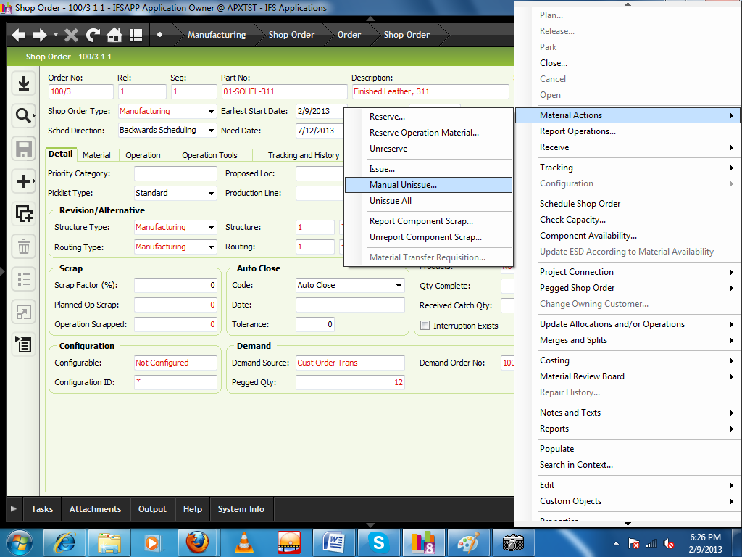
New window will be appeared.

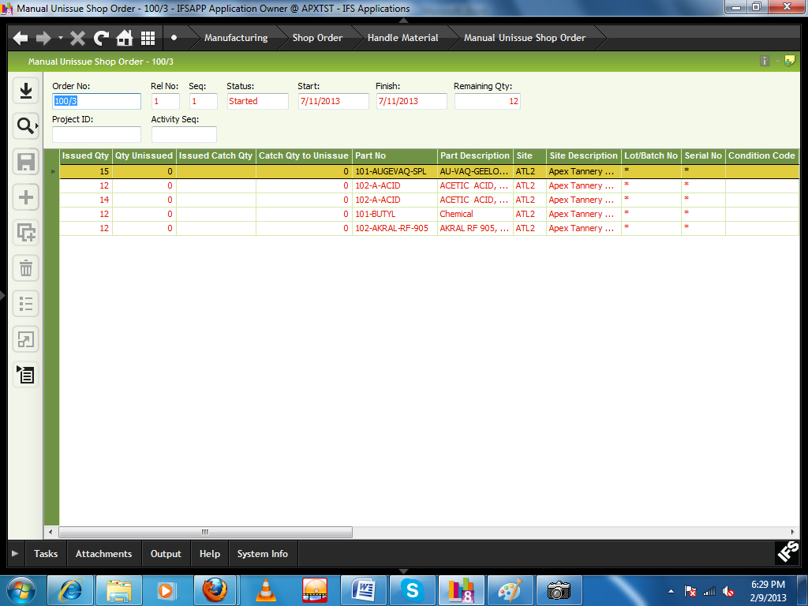
Right click of the specific material line, Click “location to unissued”
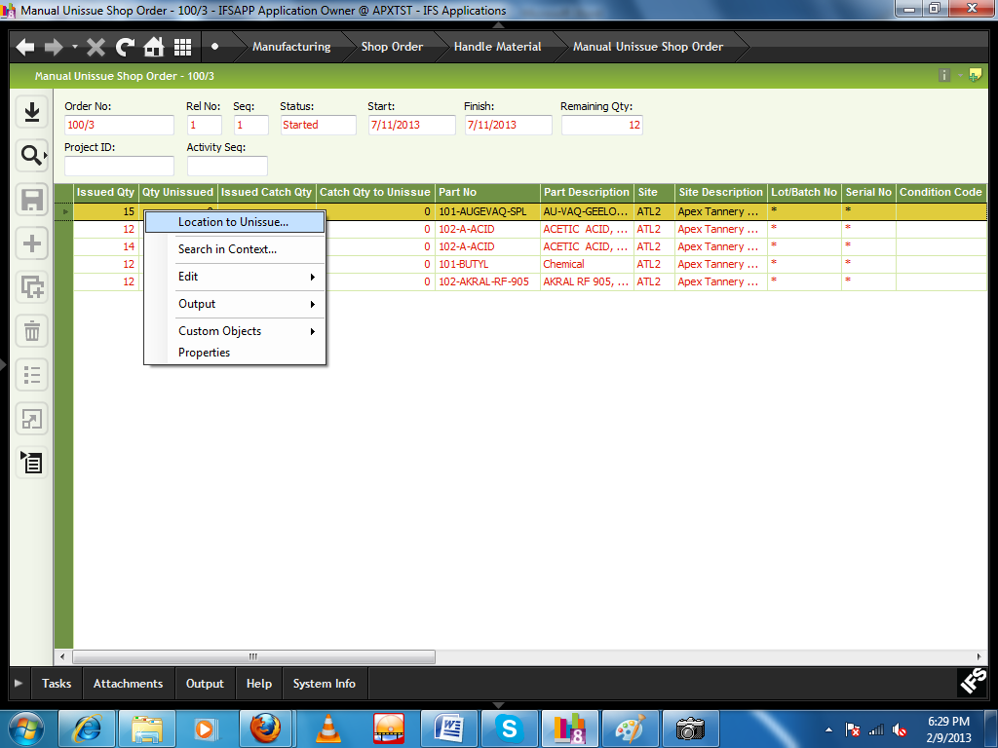
Another new window will come
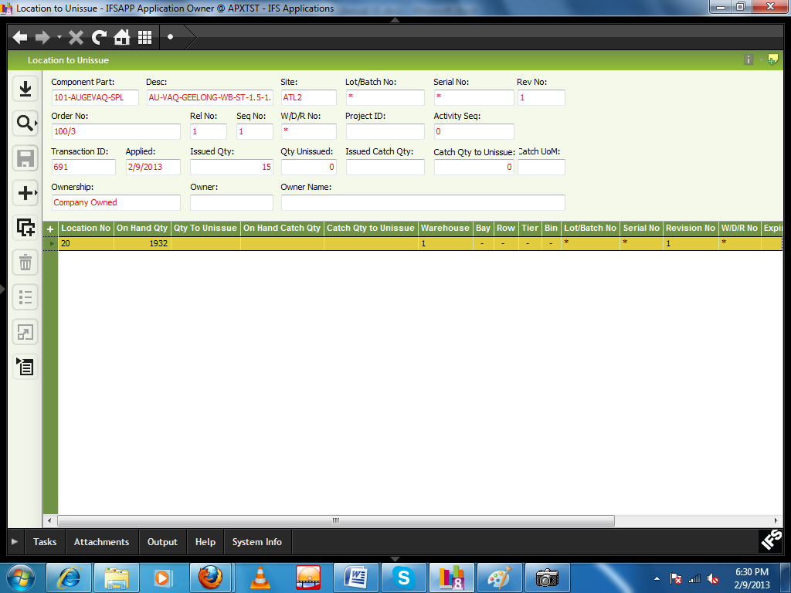
Enter the quantity you want to unissued in the “Qty to Unissue” field.
Click save button.

26) Report Operation
Path: Manufacturing\Shop Order\Order\Shop Order
Keeping cursor on header part, click RMB and select “Report Operation”. 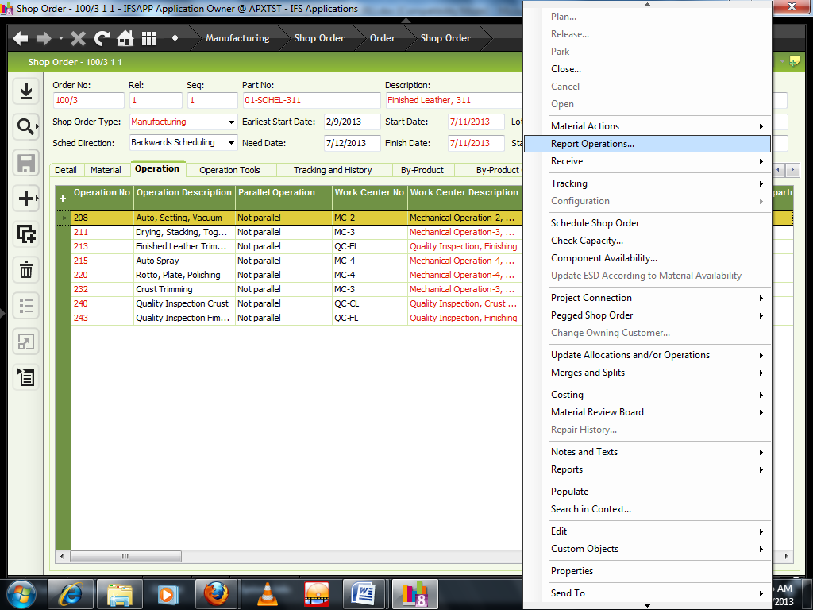
New window will be appeared.

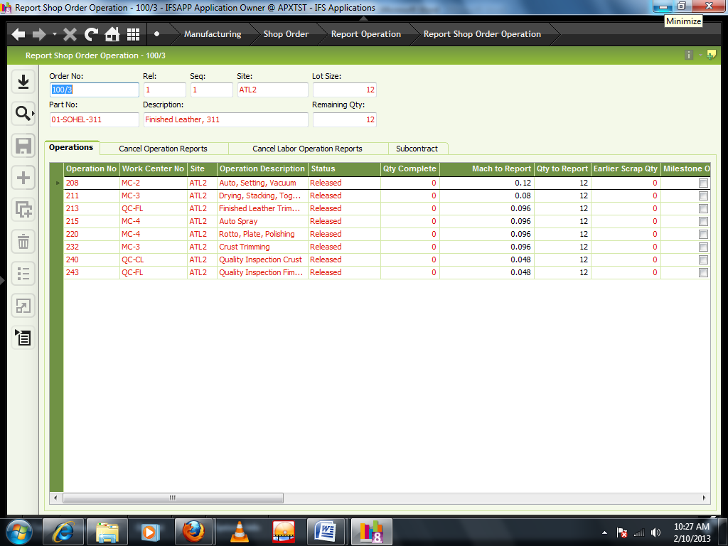
Select the particular operation row line and click RMB and select “Report Size wise quantity”

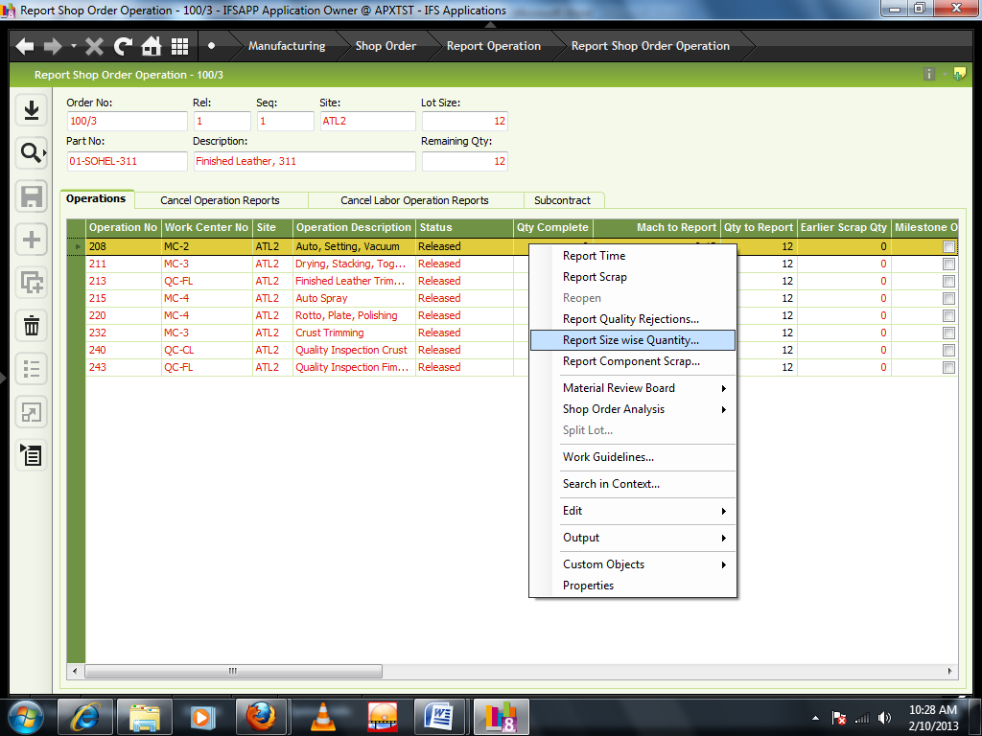
New window will be appeared

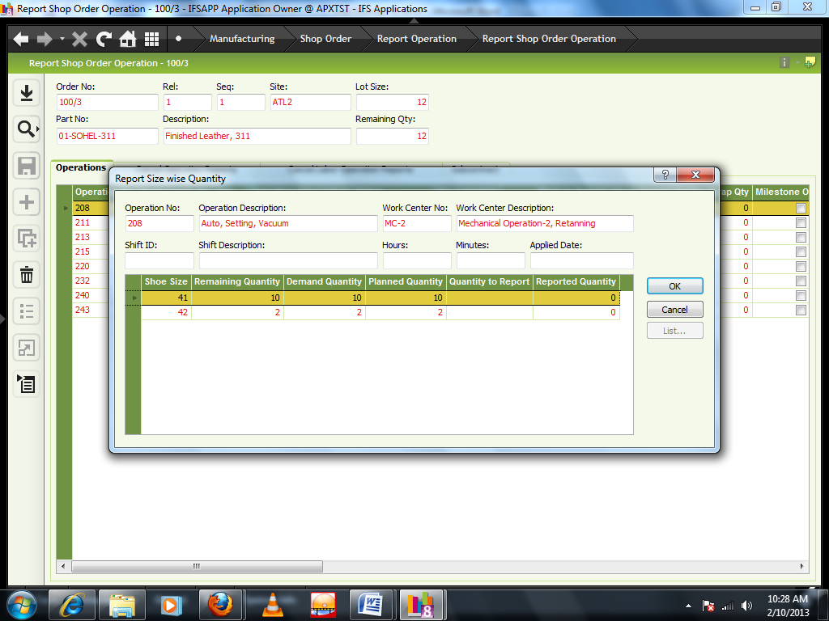
Shift ID: Enter shift id from LOV
Hours: Enter hours manually
Minutes: Enter minutes manually
Applied Date: select by double click on the field from the calendar.
Quantity to Report: Enter production quantity
Click OK button.
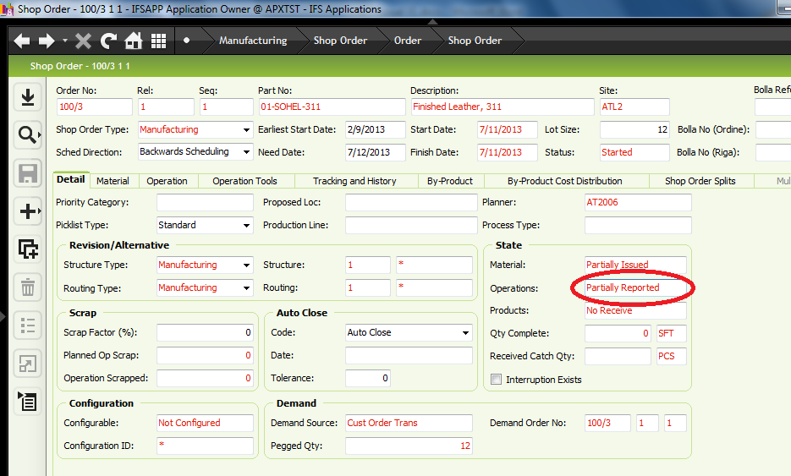
When all the quantity will be reported according to the lot size the state of Operation will be changed to “completely reported”

27) Using Size Template
We have provided the facility to use Size Templates in "Customer Order Line Size wise quantity" window.

This is now available in AST environment.

I have already created templates as “SIZE1” to “SIZE7” for all possible size categories.

RMB within the table and select the required template.
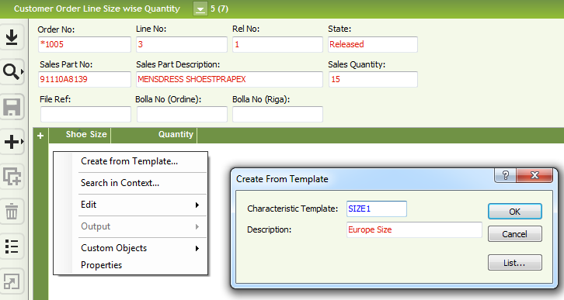

28) Cancel Report Operation
Path: Manufacturing\Shop Order\Order\Shop Order
Keeping cursor on header part, click RMB and select “Report Operation”.
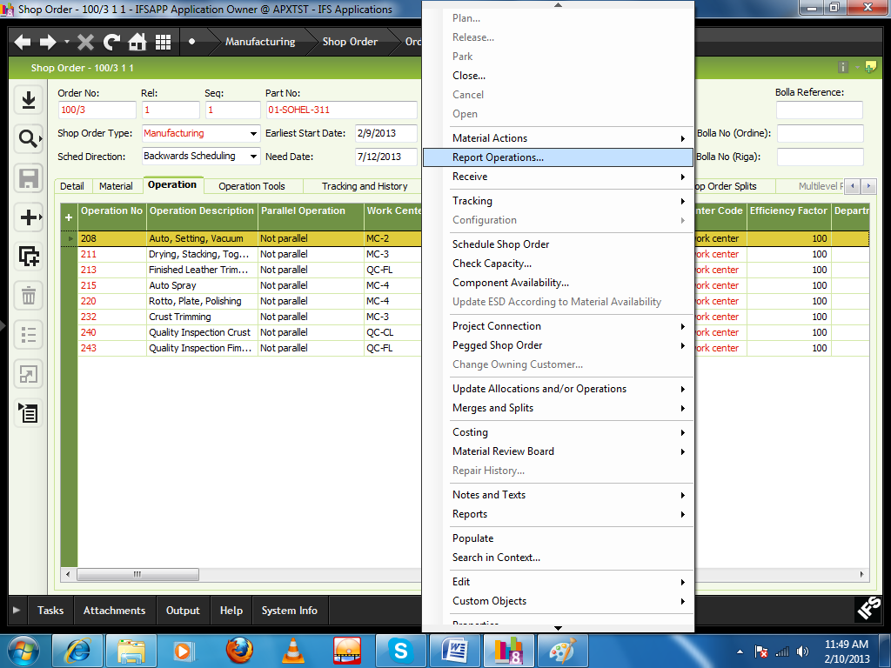
New window will be appeared.
Select “Cancel Operation Reports” tab
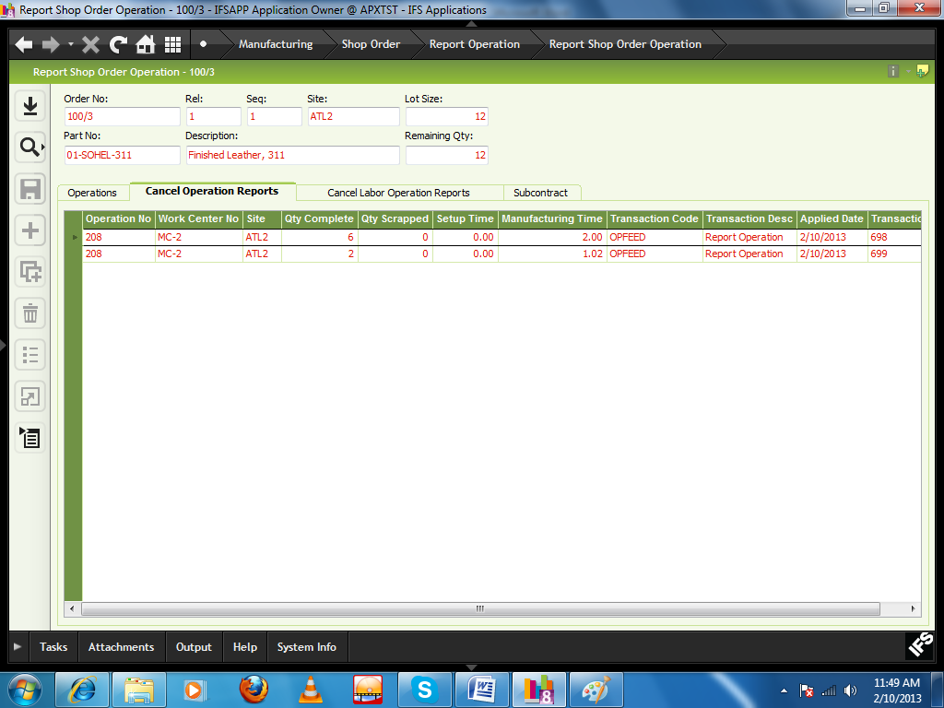
Select the specific operation reporting which you want to cancel, click RMB and click “Cancel”

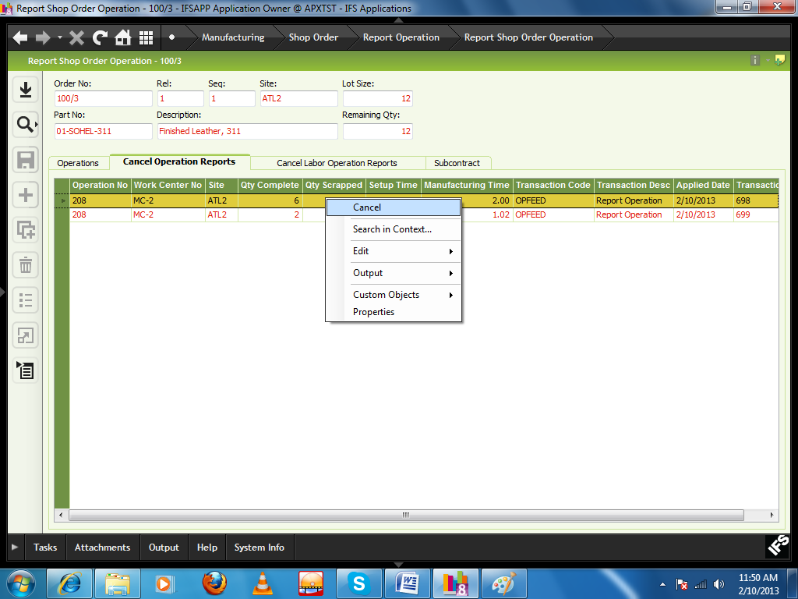

29) Core Line Manpower Entry

A new window is introduced under Manufacturing\Shop Order, named “Core Line Manpower Detail”

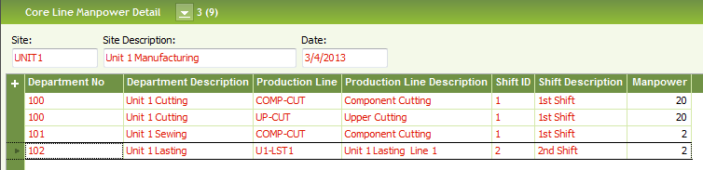

Create a new Record in Header

Select the Site from LOV

Enter a Date

Save

Create a new record in the table

Select the Department from LOV
(LOV from Work Center Departments)

Select the Production Line from LOV
(LOV from Production Lines)

Select the Shift from LOV
(LOV from Basic Data for Quality Rejections)

Enter the Manpower manually

Save

- Header cannot be duplicated
- Line cannot be duplicated within one header record (combination of Department, Production Line and Shift)

NB: In this “Core Line Manpower Detail” window we need to select department and production line from LOV. In AST it has been decided that Core line manpower entry will be “Work Center “ wise instead of dept and production line.

30) Rework and Re control

31) Receive
Path: Manufacturing\Shop Order\Order\Receive Shop Order
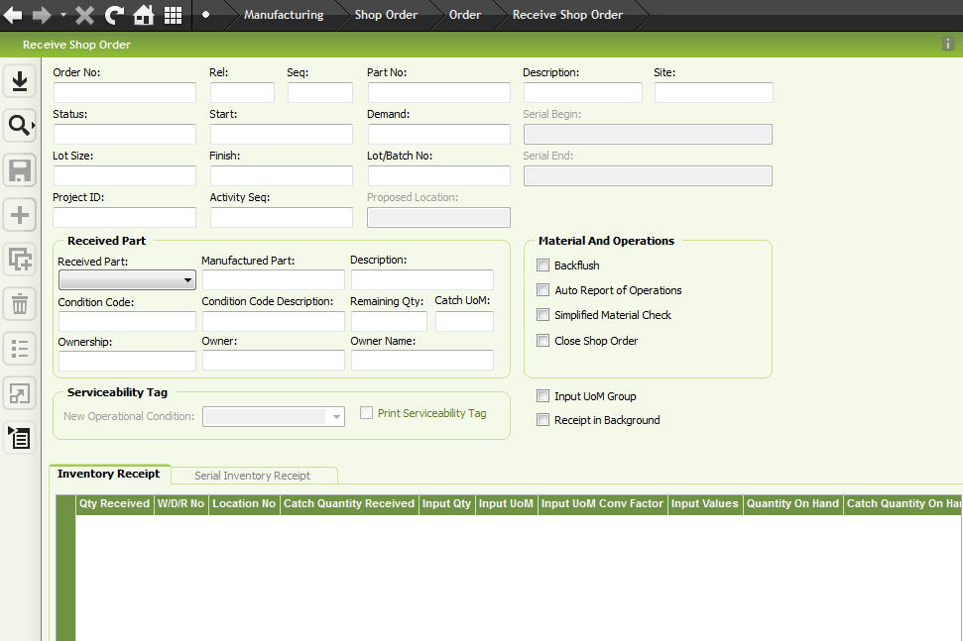
Click Search button and select the respective order no.
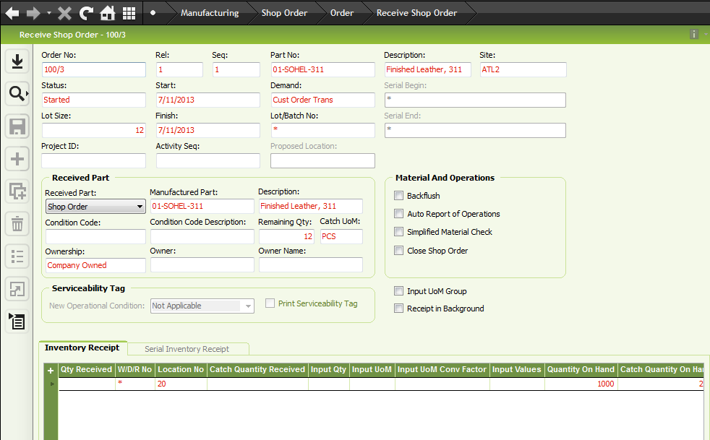
Qty Received: Enter receive quantity
W/D/R: Enter the size of shoe
Location no: Enter the location no you want to store.
Click save button.
When all the quantity will be received according to the lot size the state of “Product” will be changed to “completely received”
When the state of the product is in completely received condition then shop order will be closed.

32) Quality Rejection
Path: Manufacturing\Shop Order\Order\Shop Order
Keeping cursor on header part, click RMB and select “Report Operation”.

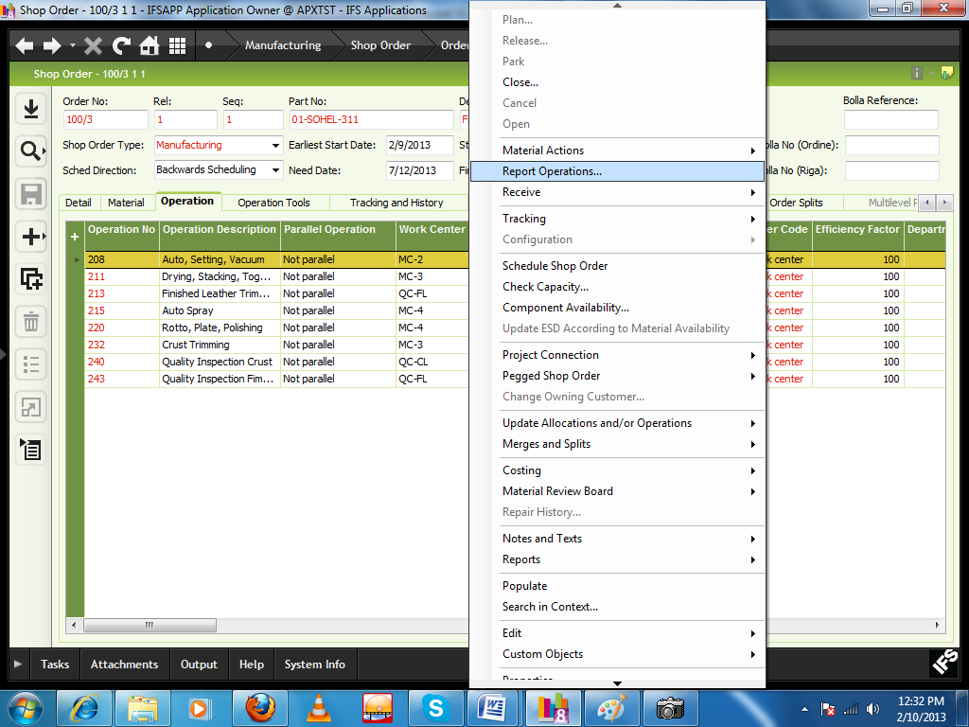
New window will appear
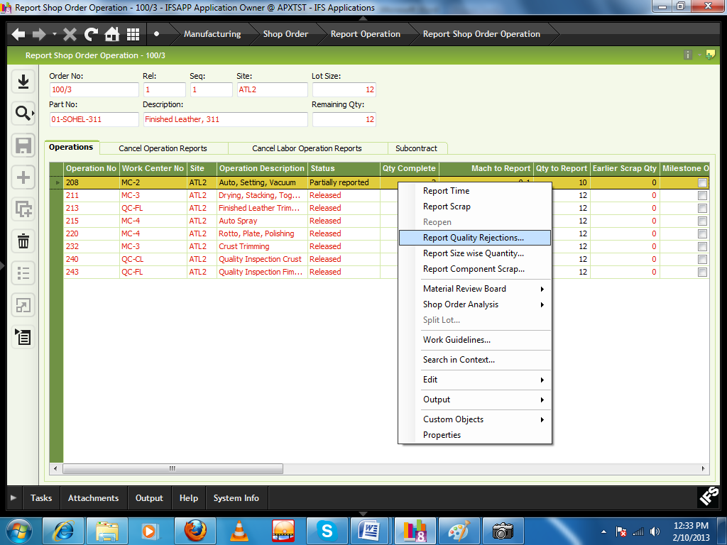

Select the operation no row against which you want to report rejections and click RMB and select “Report Quality Rejection”
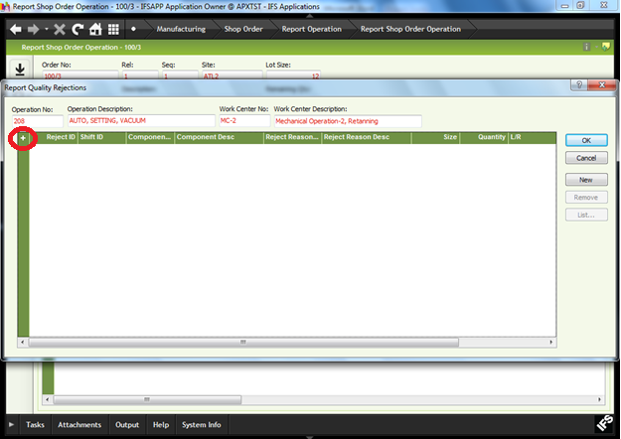
Click on “+” button.
New line will appear for entering the data.

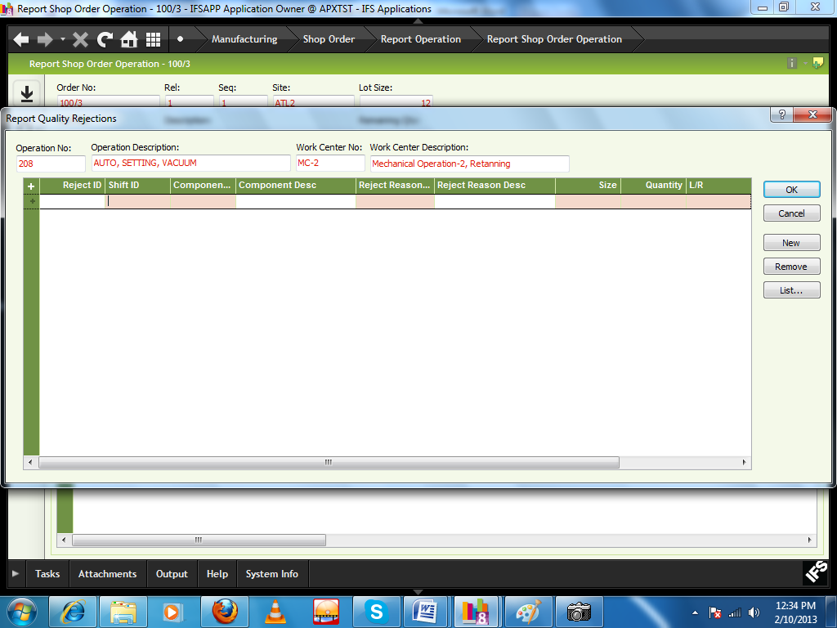
Shift ID: select from the LOV
Component No: select from the LOV
Reject Reason: select from the LOV
Size: select from the LOV
Quantity: Enter manually
L/R: select from the combo
Applied date: By double click select date from calendar.
Click Ok button.

33) Re cutting
Path: Manufacturing\Shop Order\Order\Shop Order
Select “Re-Cutting Details” Tab
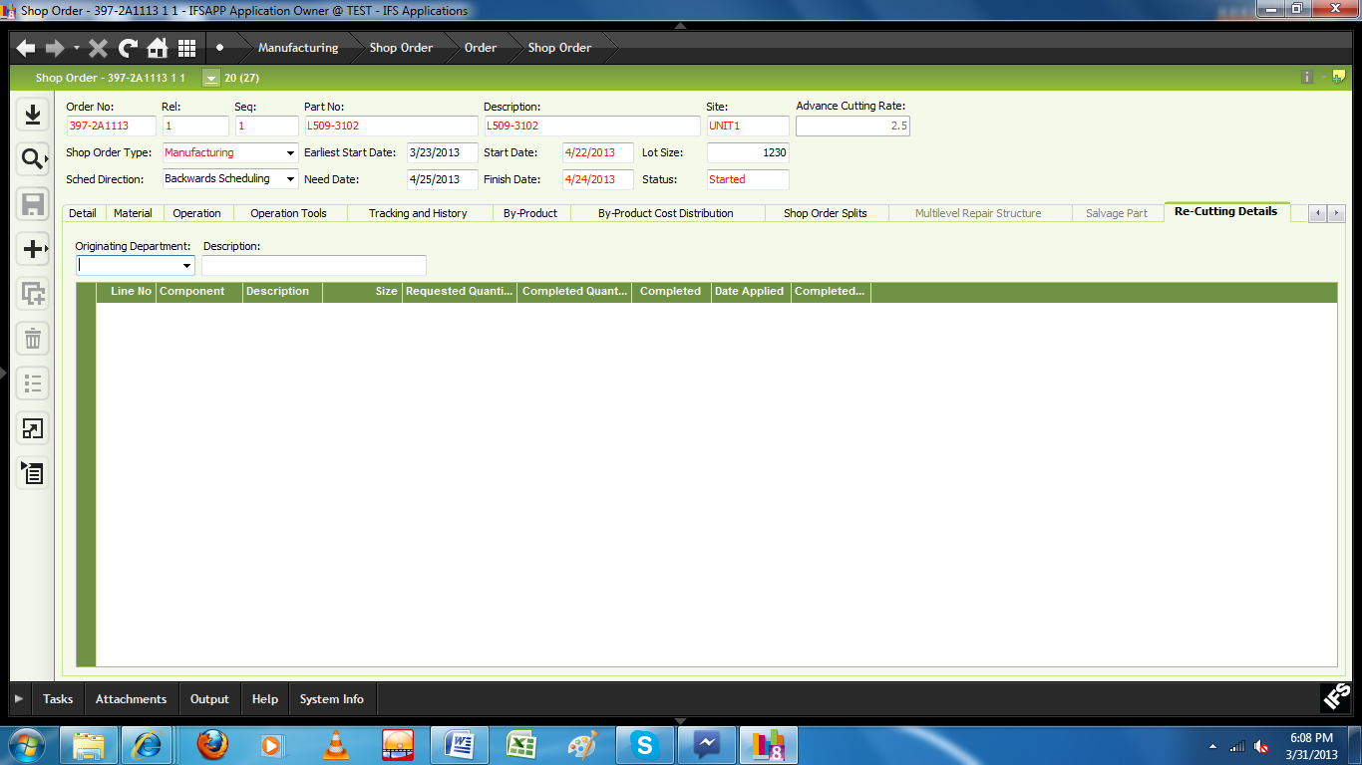
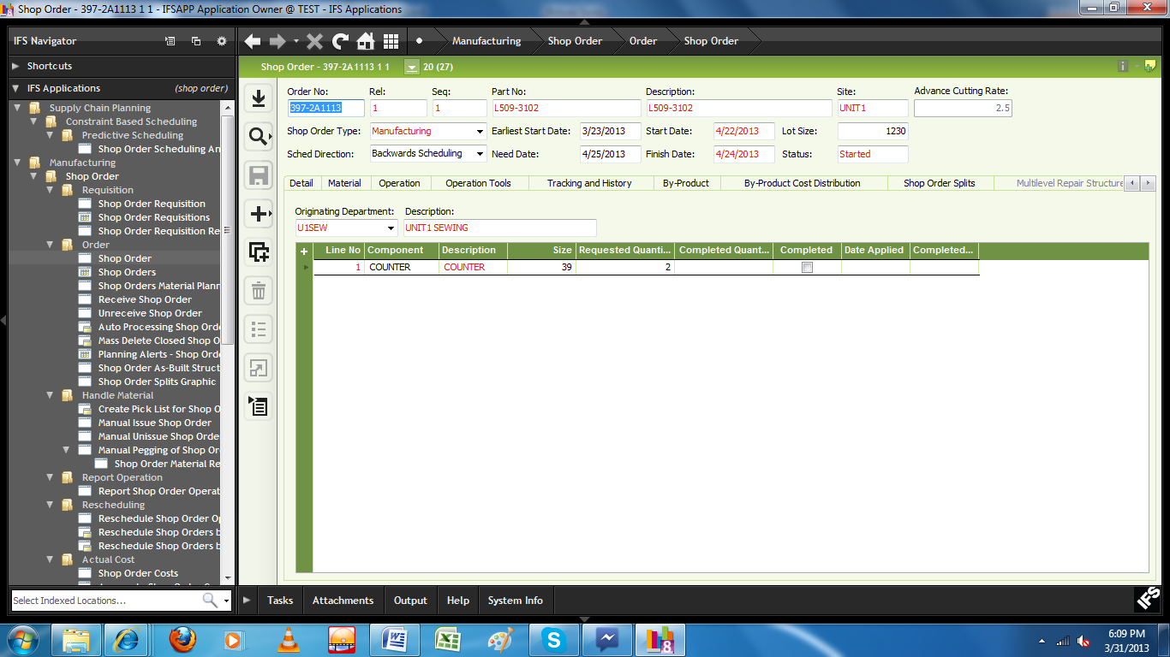
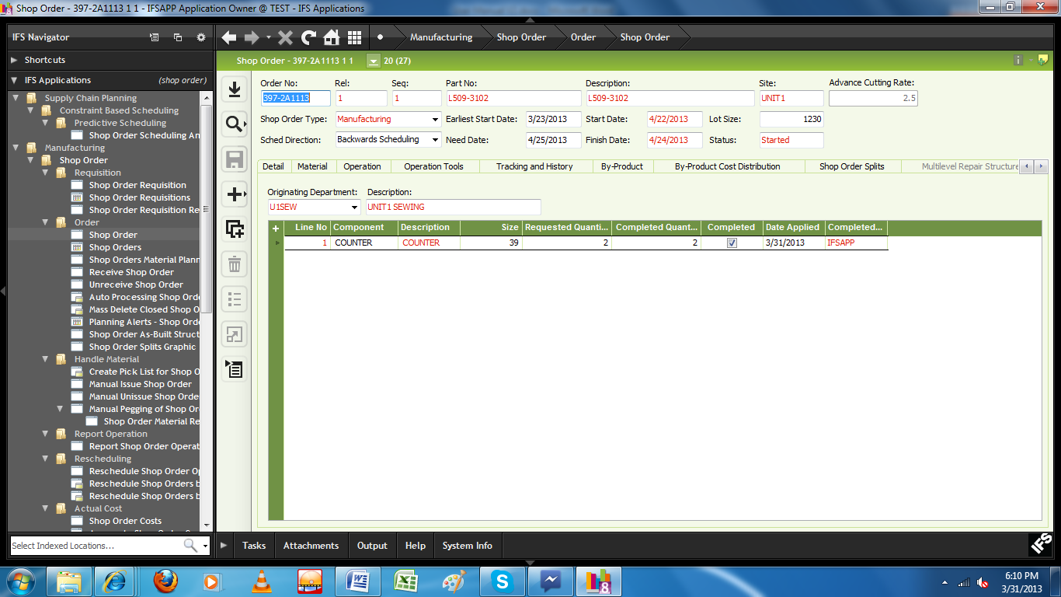

User has to create a new record, enter the data as below and save the record.
Originating Department | Manual entry from LOV | LOV will have departments defined under  Engineering\Manufacturing  Standard\Basic Data\Manufacturing  Standard Basic Data-Work Center Departments
Component | Manual Entry From LOV | LOV will have Components defined under  Manufacturing\Shop Order  \Quality Rejections\Basic Data for Quality  Rejections-Components
Size | Manual Entry from LOV
Requested Quantity | Manual entry
Date | Manual entry
User ID | System will take the ID of the data entry User
Complete | Check box
• Material can be requested separately for re cutting
NB: For re cutting reporting of sewing, moccasin and Lasting, a new customization will be offered by IFS.

34) Create Moccasin Work center
Path: Engineering\Manufacturing Standard\Work Center and Production Line\Work Center
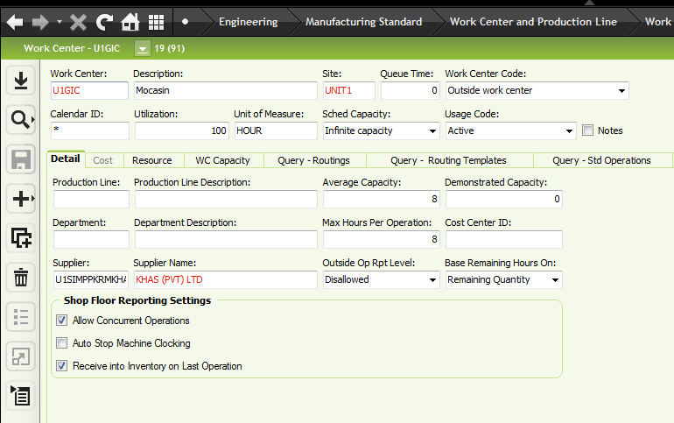
Work center: Create manually work center id
Description: enter description of work center
Work center code: select “outside work center” from the list.
Average Capacity: Enter per hour production capacity
Click save button.

35) Moccasin Operation
Path: Manufacturing\Shop Order\Order\Shop Order
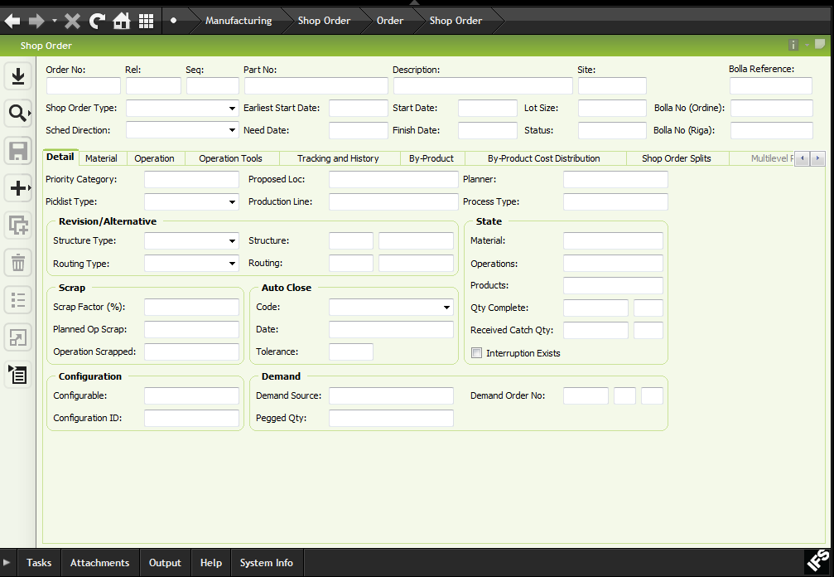
Click search button and select respective shop order
Click RMB and select “Report Operations”
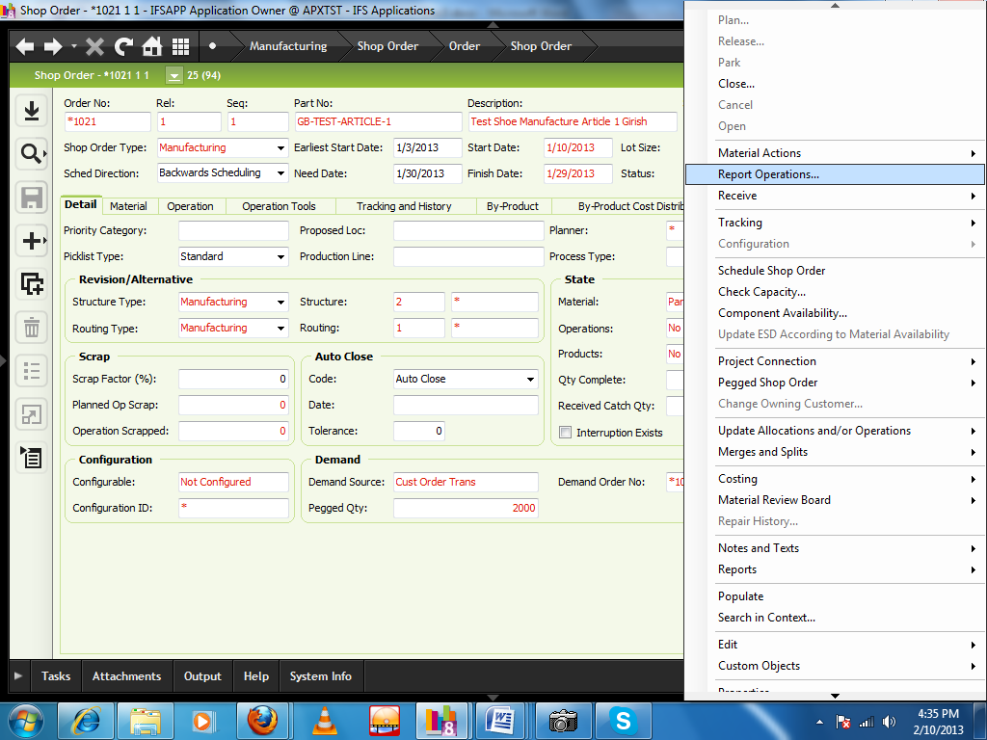
New window will be appeared
Select “subcontract “ tab
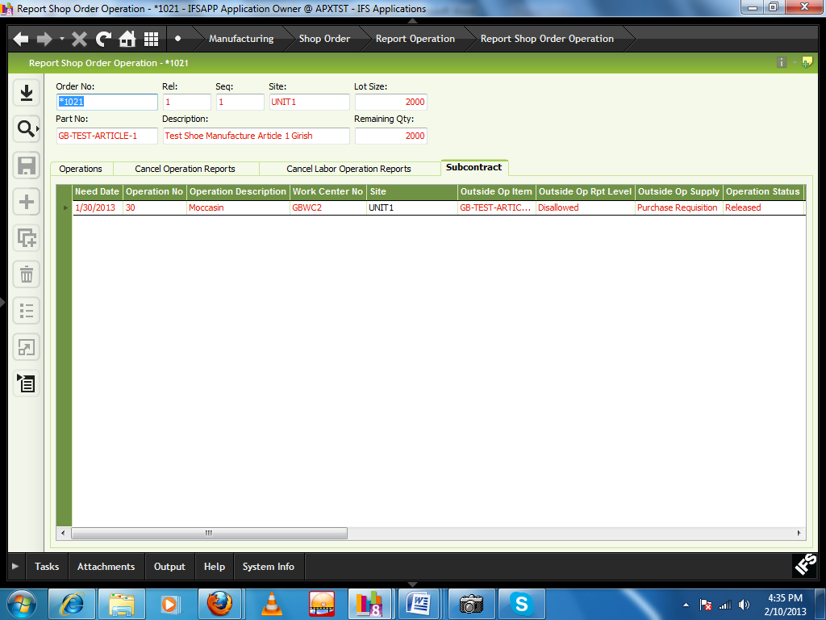
Select the respective row and click RMB and select “Ship WIP to Supplier”.
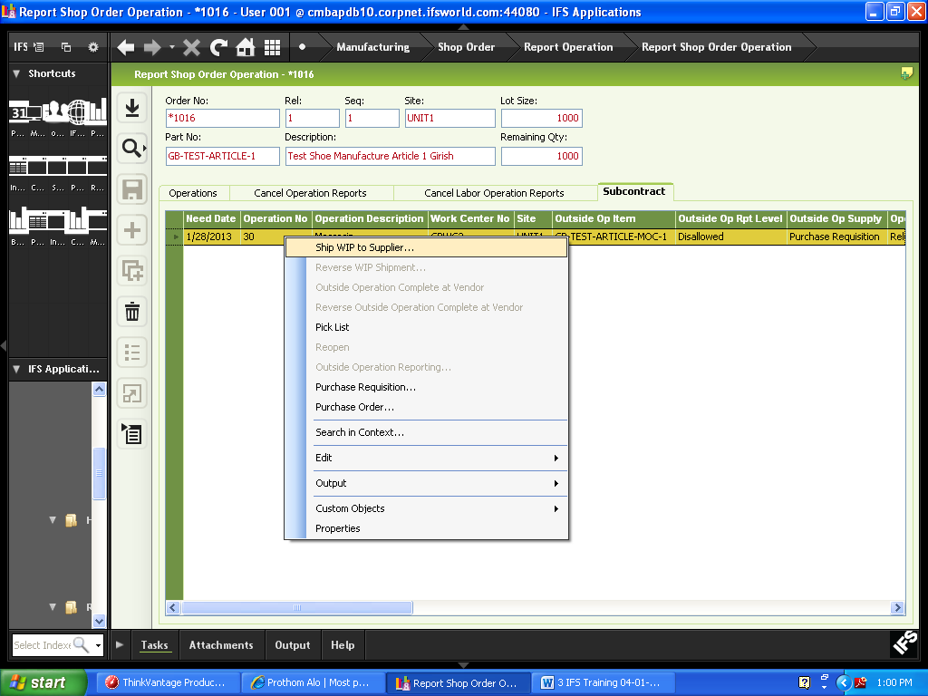
Pop up window will be appeared
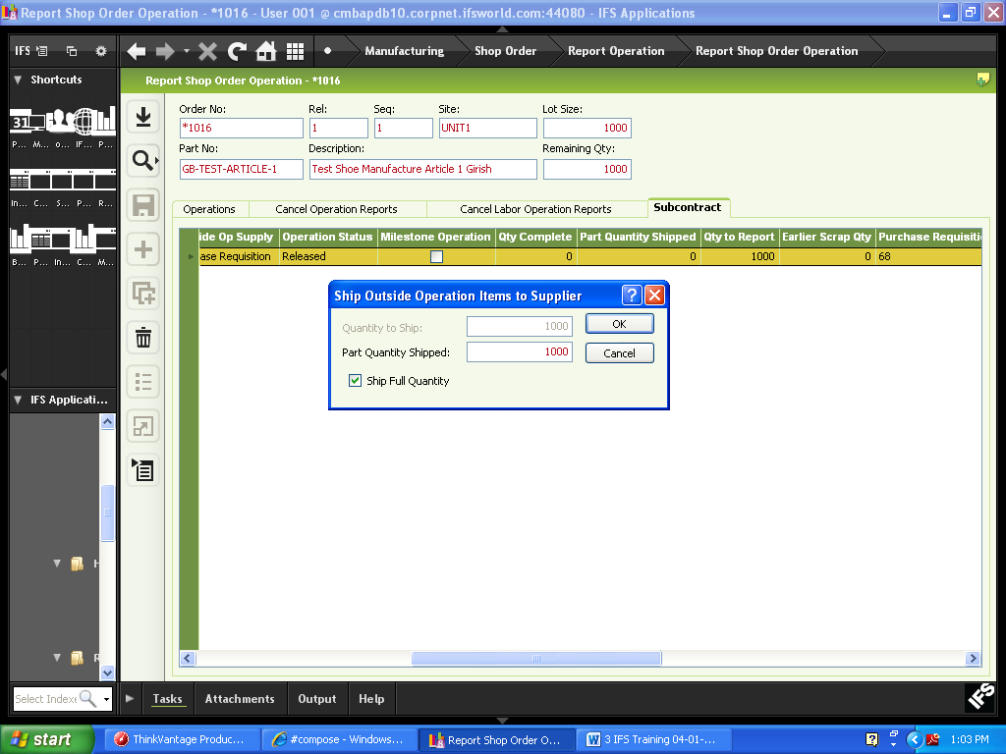
Part Quantity Shipped: Enter the quantity
Click RMB and click “Purchase Requisition”
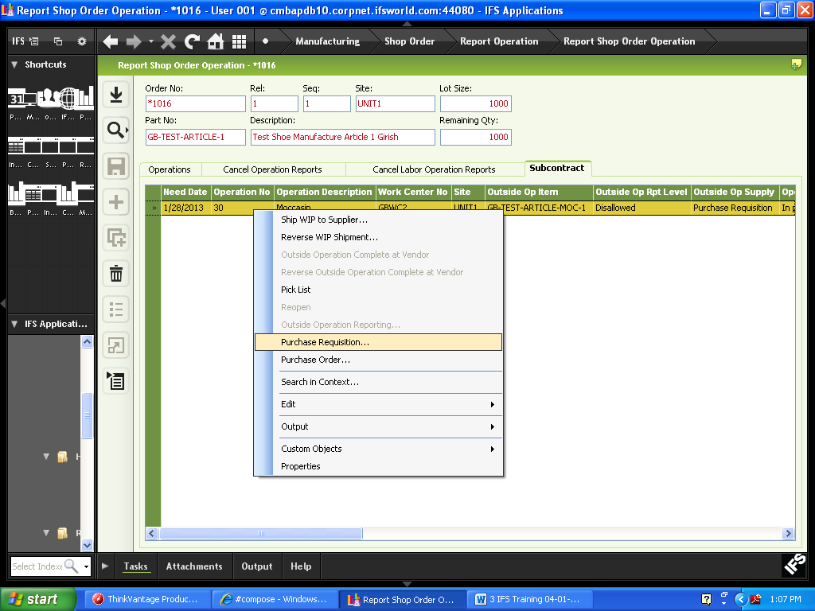
New window will be appeared
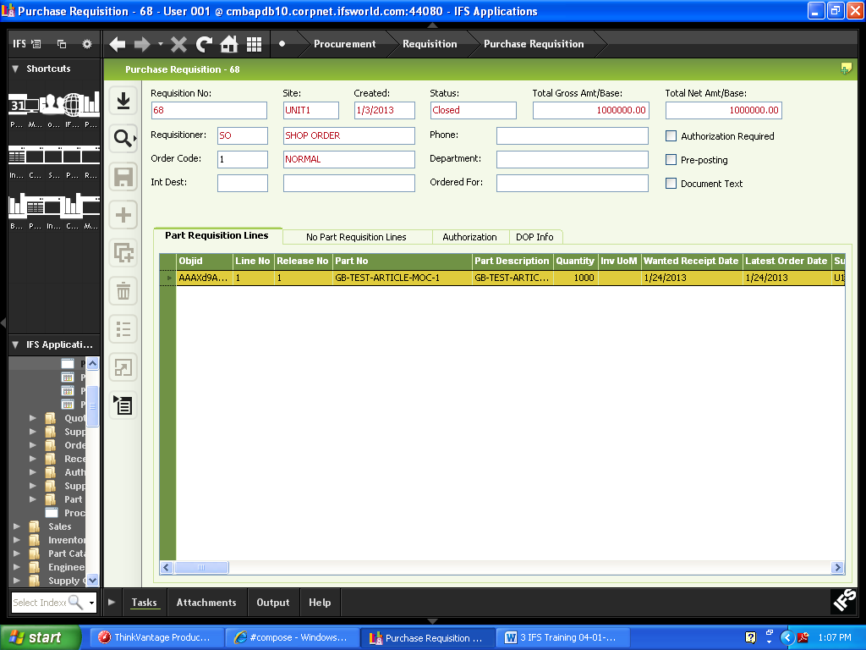
Click RMB and select “Release”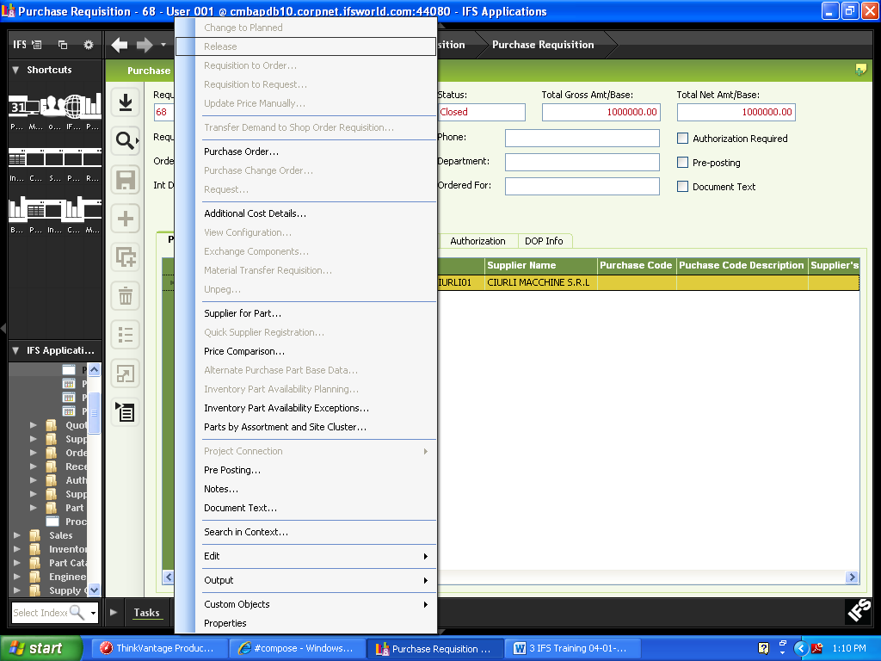
Click RMB and select “Purchase Order”
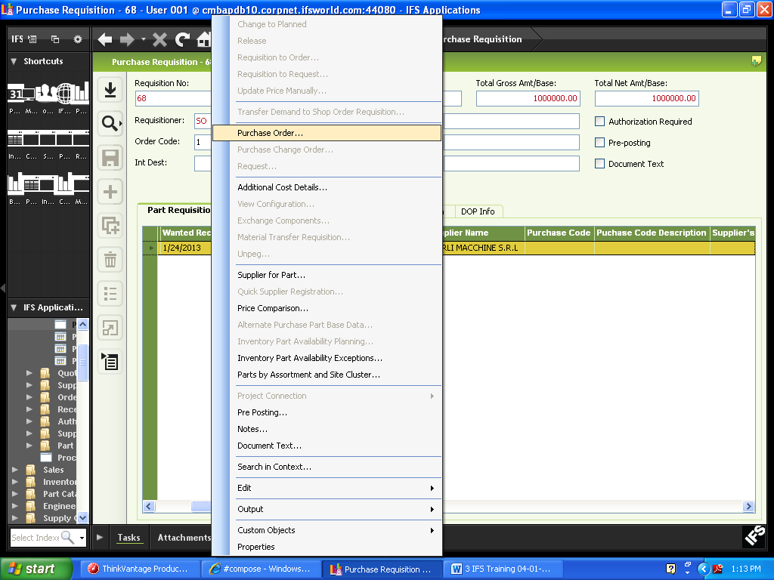
New window will appear
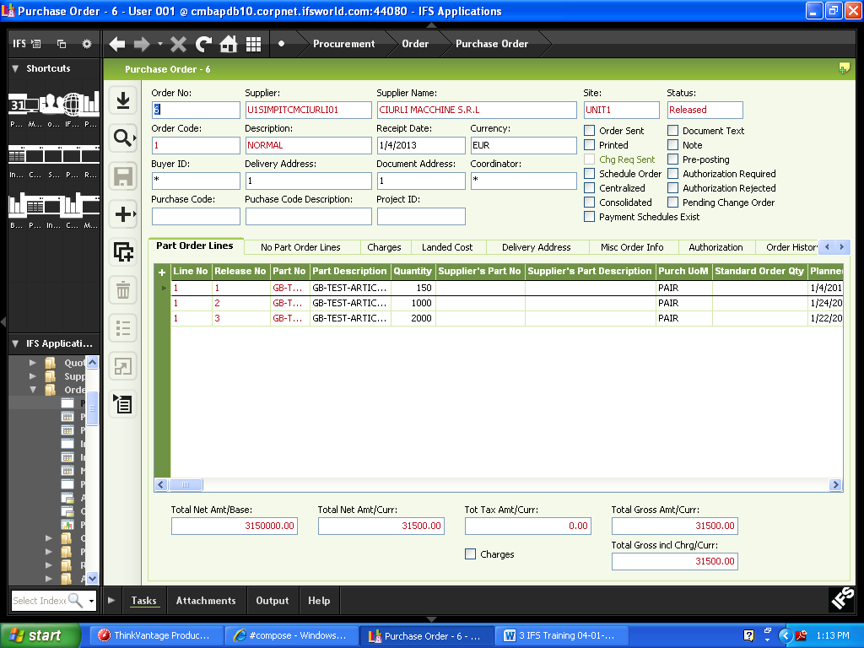
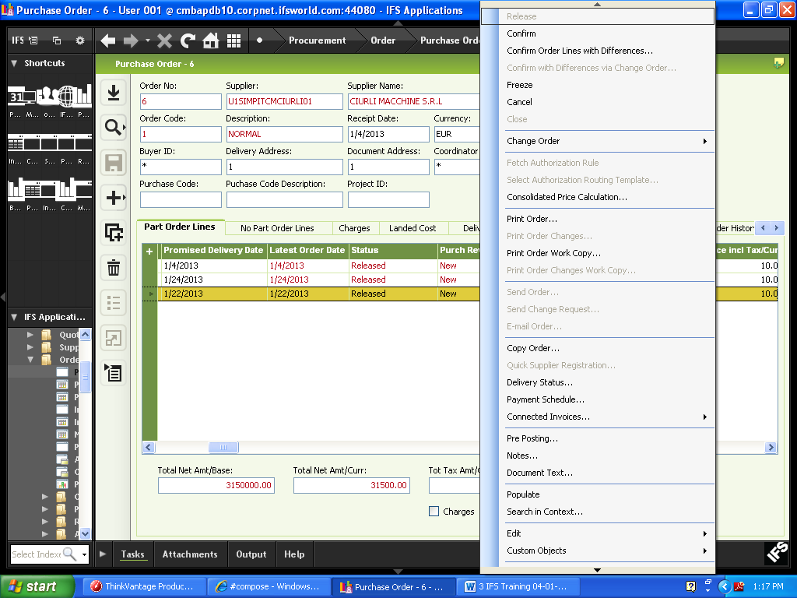

Click RMB and select “Release”
Path: Procurement\Receipt\Register Purchase Order Arrivals
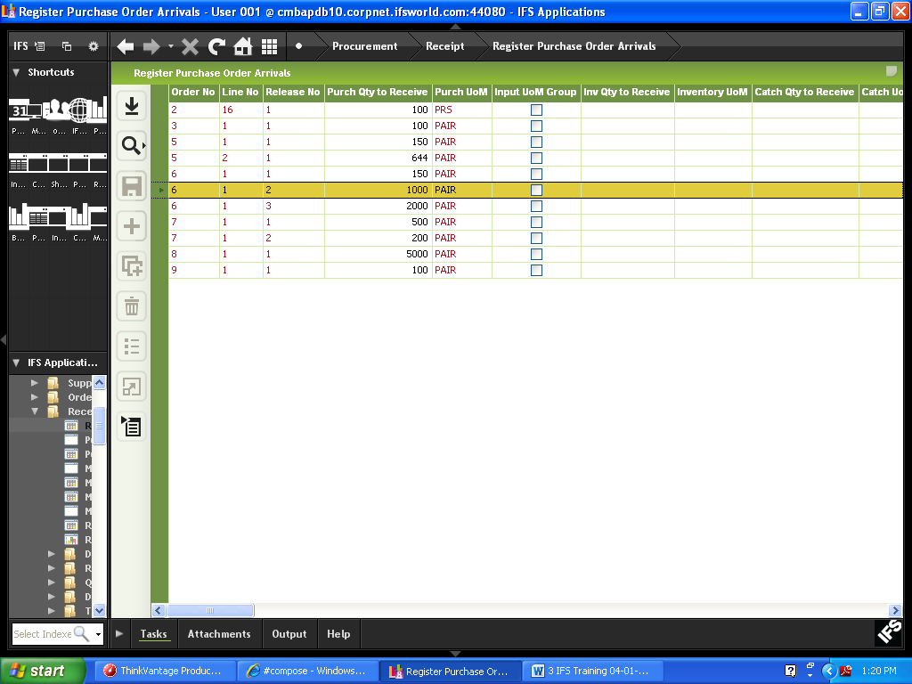
Select the respective purchase order no, click RMB and select “Receive Order”
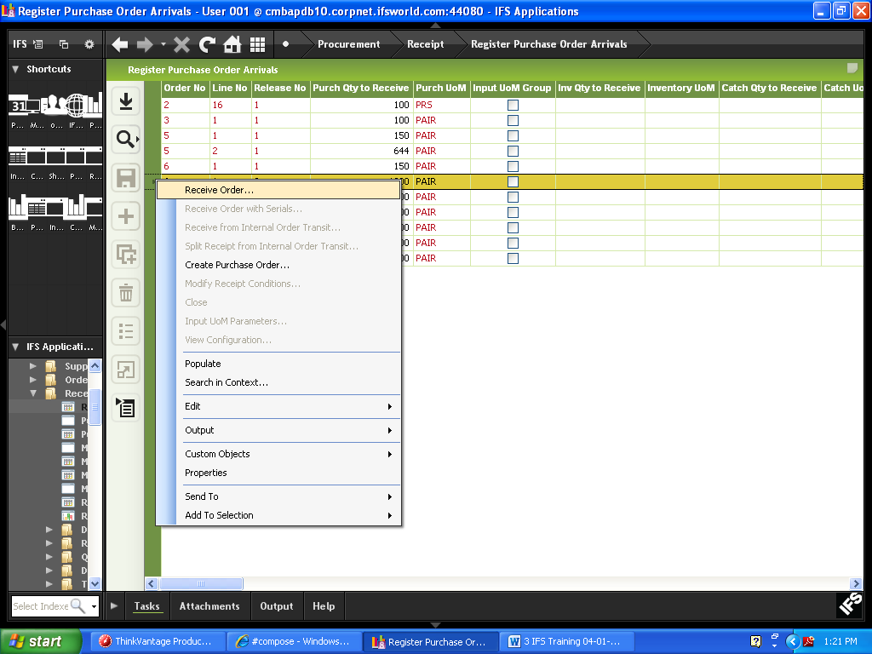

A pop up window will be appeared

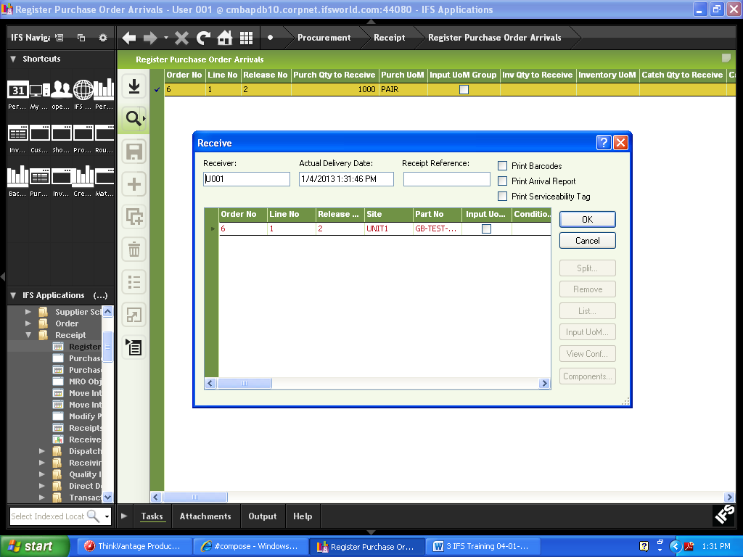
Purch Qty to Receive: Received quantity
Receive Case: select receive case from combo
Location No: select location no from LOV
Click OK button

36) Semi Finished Goods -SFG

In case of batch production we have to go for multi level product structure and consider the product as SFG.
For creating the product structure of Finished Goods –FG we have to add the semi finished good as raw material.
Then select the SFG grid line, click RMB and select “Next Level”
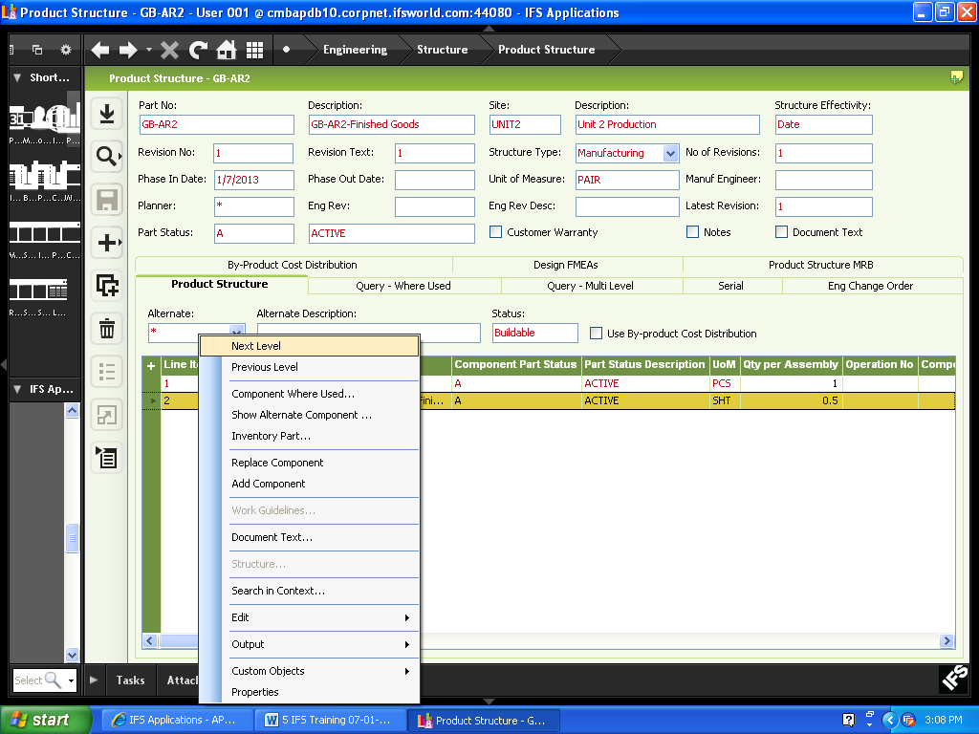
New window will come where we will get the opportunity to create the product structure and routing for SFG.

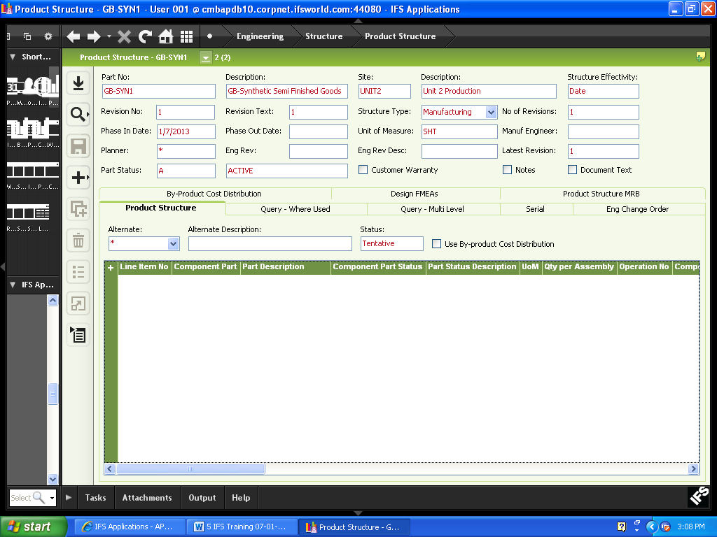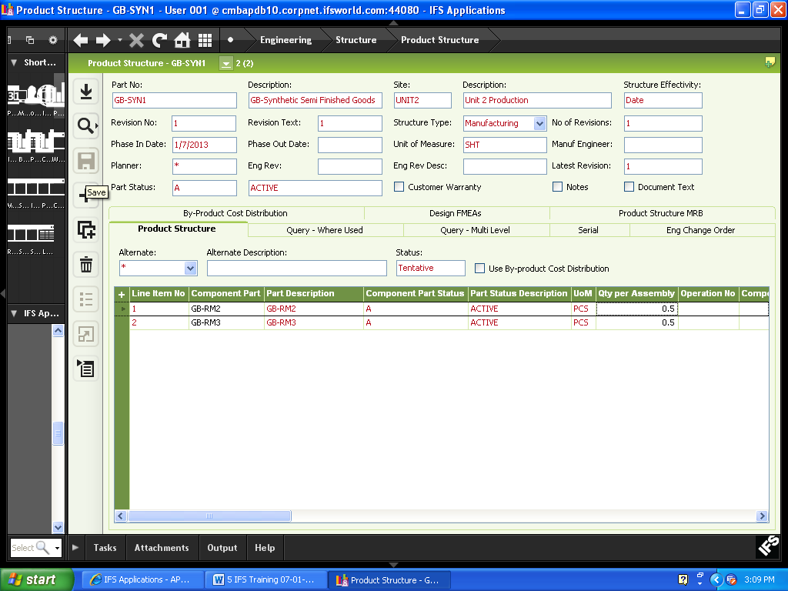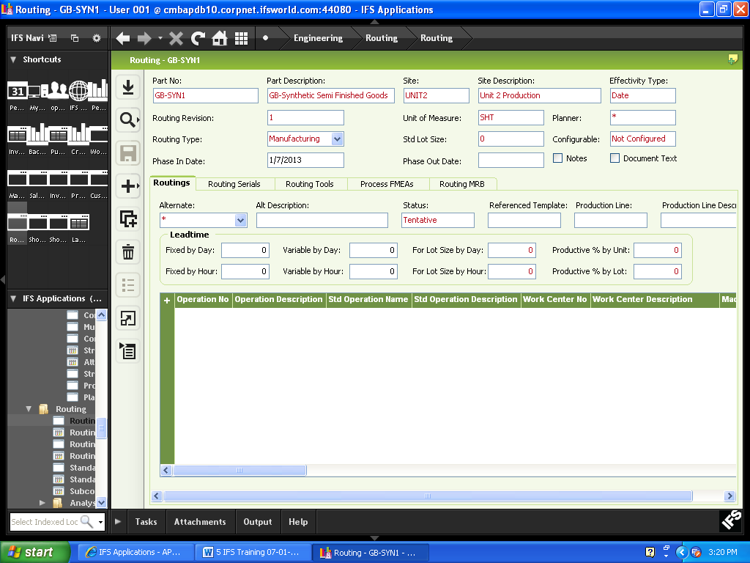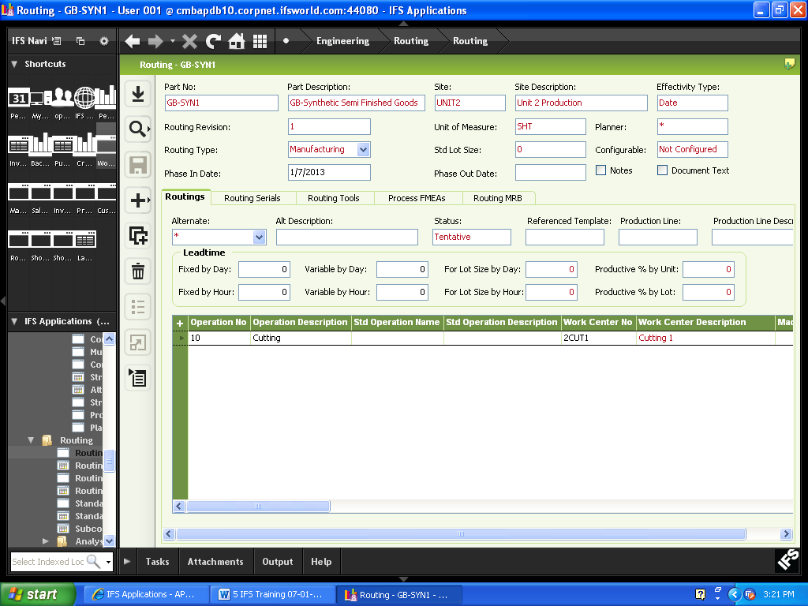
Shop Order:
Path: Manufacturing\Shop Order\Order\Shop Order
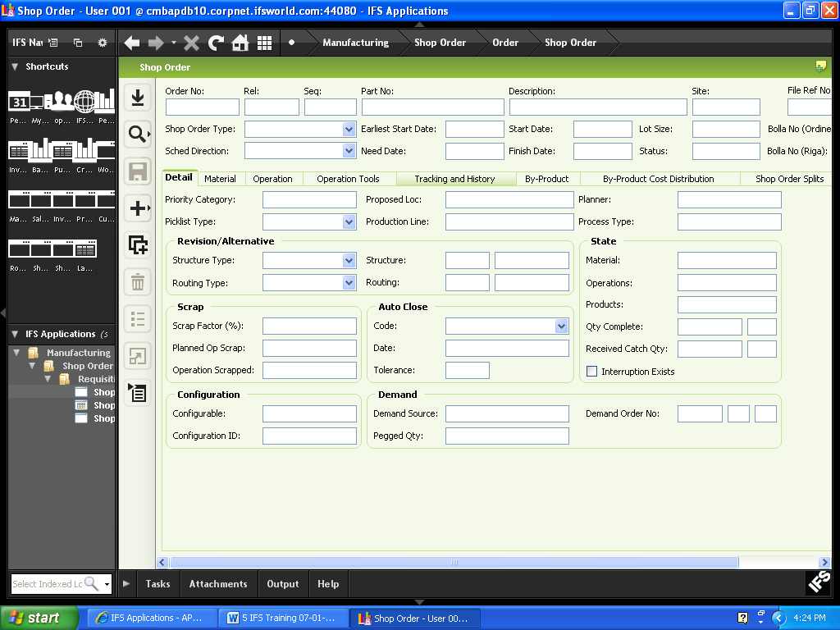
Click search button and select the respective finished goods shop order in which SFG exists as raw material.
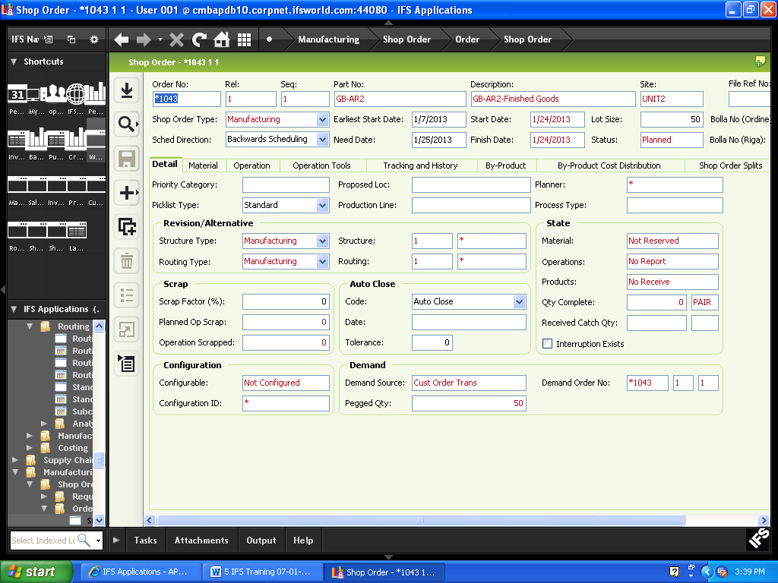

After releasing the shop order we have to execute MRP process
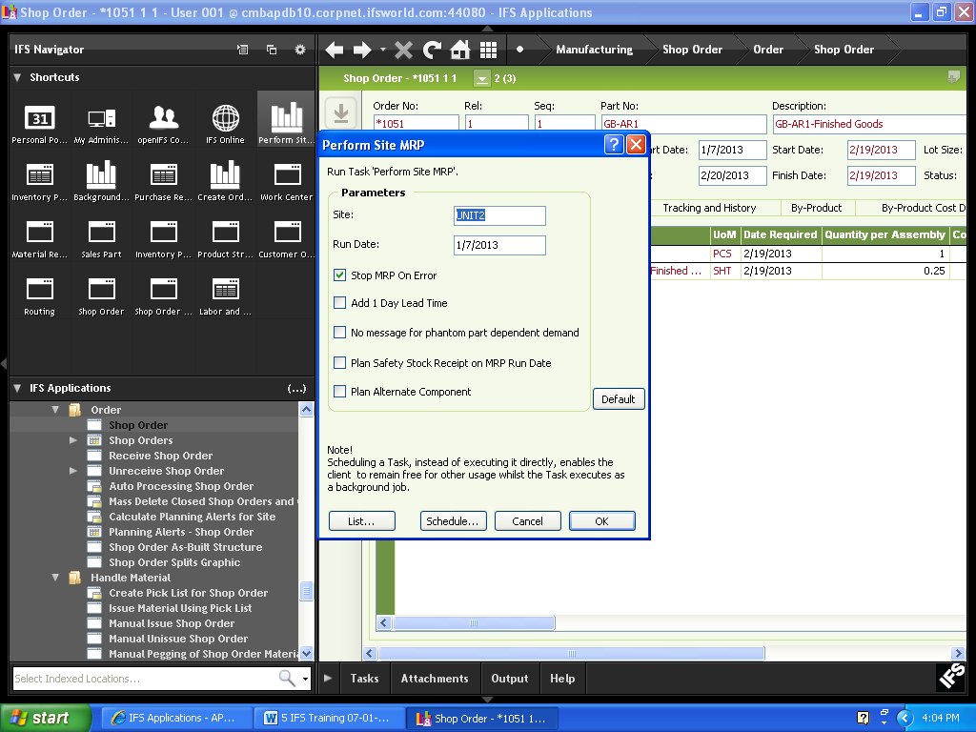
Click ok button

After performing the MRP system will create purchase requisition for purchase raw materials and shop order requisitions for SFG
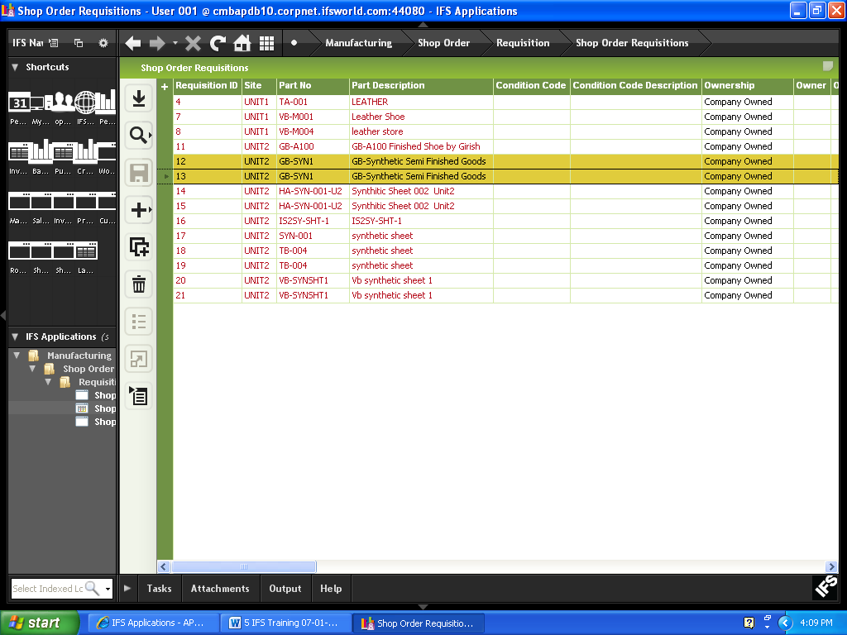

Planner has to decide which requisitions he needs to merge for planning and executing purpose considering all the scenarios.

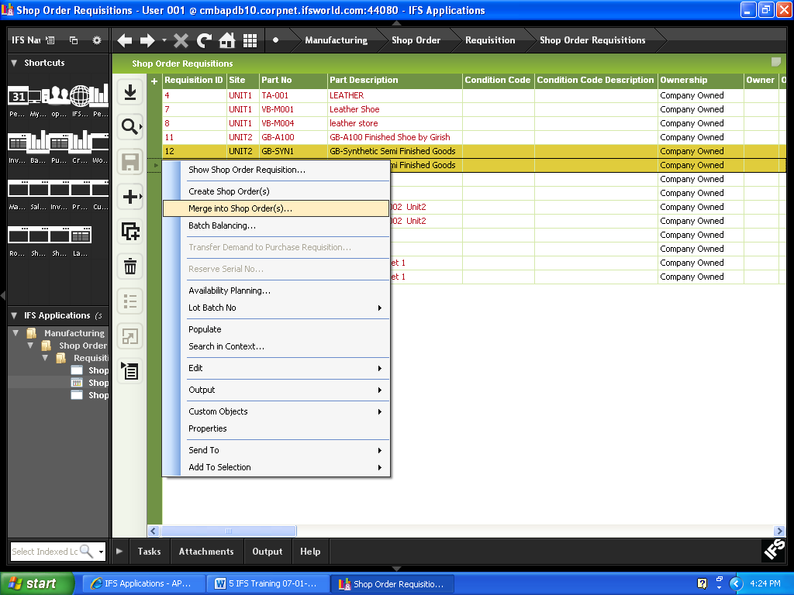
For merging he has to select the shop order requisitions, click RMB and select “Merge into shop order(s)”
A new pop up window will come

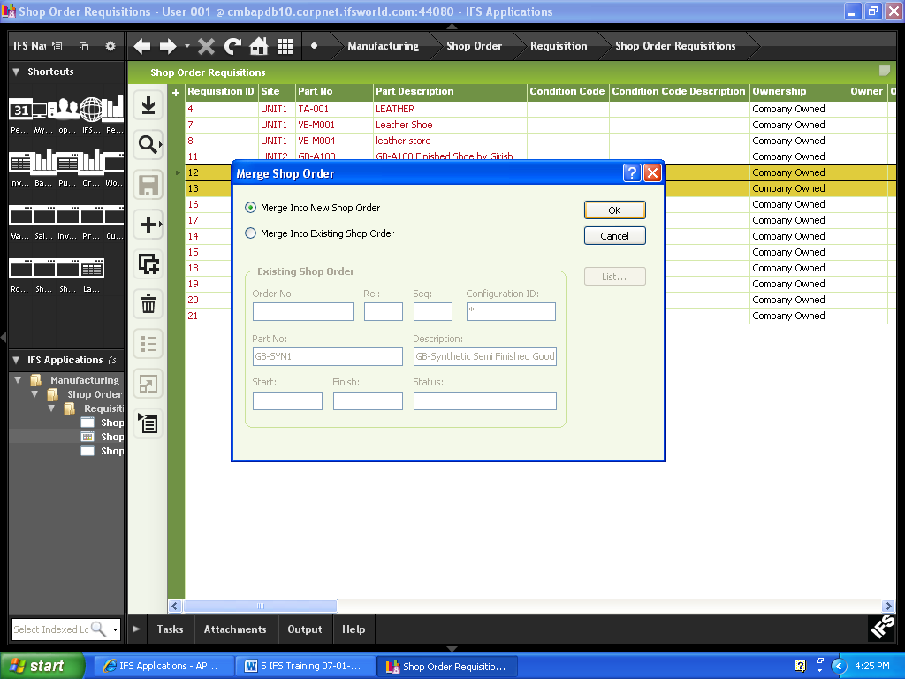
Select “Merge into new shop order” and click OK button.

A new shop order will be created for executing the SFG
Now we have to execute all the similar steps which we have done for completing a shop order.
When the SFG will be received in store we can check the material availability against the particular article and also issue against the shop order (Finished Goods)

37) Handling Outsole
Given below is how Outsole will be handled as SFG in IFS.

- Register Outsole as “Manufactured” inventory parts. One Part No for all sizes of one Outsole.
- Create product structure and Routing for outsole.
- Enter Outsole as a material in the Product Structure for the Article.
- Customer Order is created for the Article and there will be a system generated Shop Order for the Article. (Standard procedure we discussed in the training)
- MRP will calculate the requirement for the Outsole and will generate Shop Order Requisitions for the Out Sole, which will be converted in to Shop Orders.
- Outsole requirement is calculated by MRP without considering the size. You will have to manually calculate the size wise requirement. You may generate reports to assist this process. These reports can be generated by APEX IT team.
- You can manually enter the size wise requirement for outsole under “Size wise quantity” tab in the Shop Order for the outsole.
- Production reporting, Quality rejections can be done size wise if you have entered above size wise quantity.
- When receiving outsole in to inventory, size can be mentioned under W/D/R No, so stocks will be maintained with the size against one Part No.

Inventory Part in Stock:

Path: Inventory\Quantity in Stock\Inventory Part In Stock
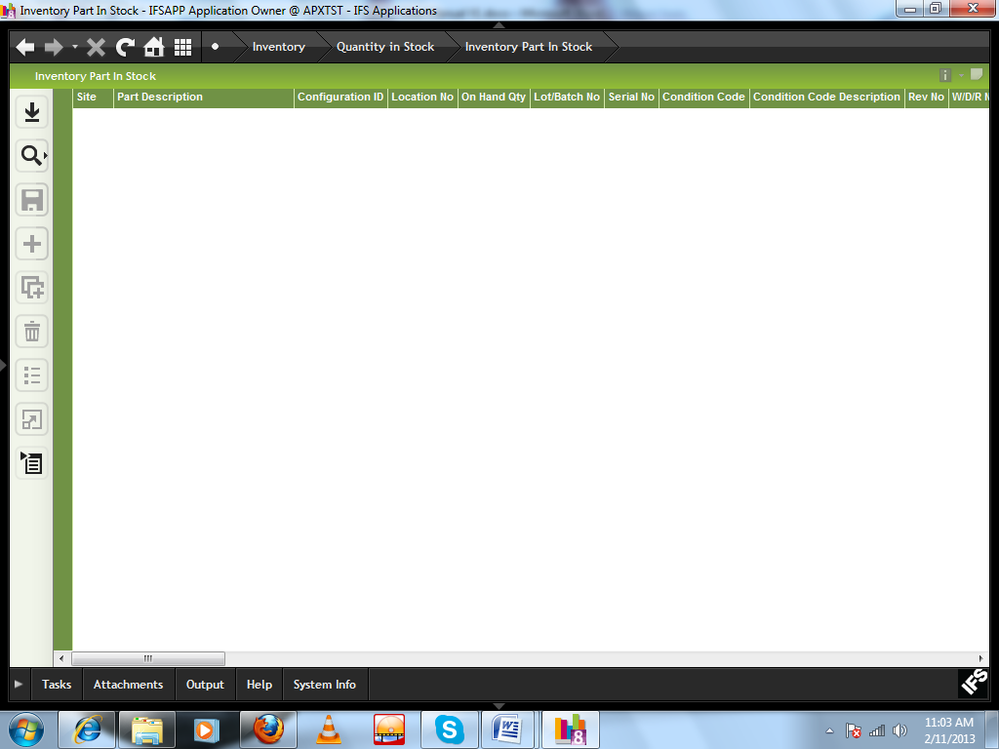

Click search button
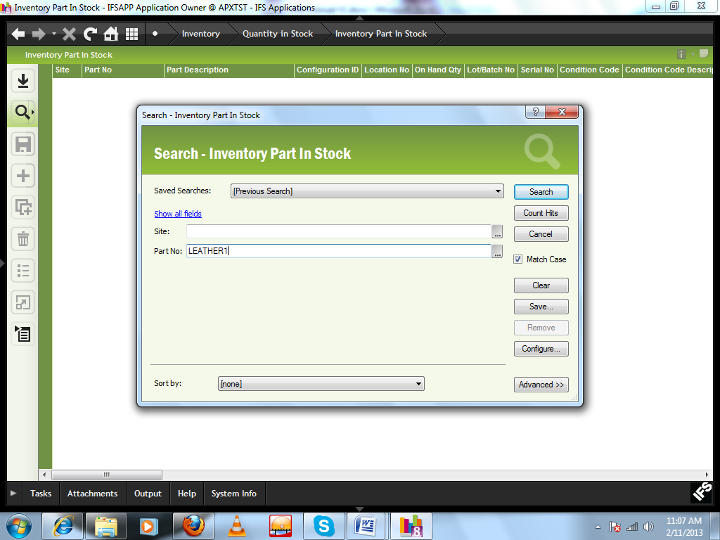

Search for the respective part no and find the stock

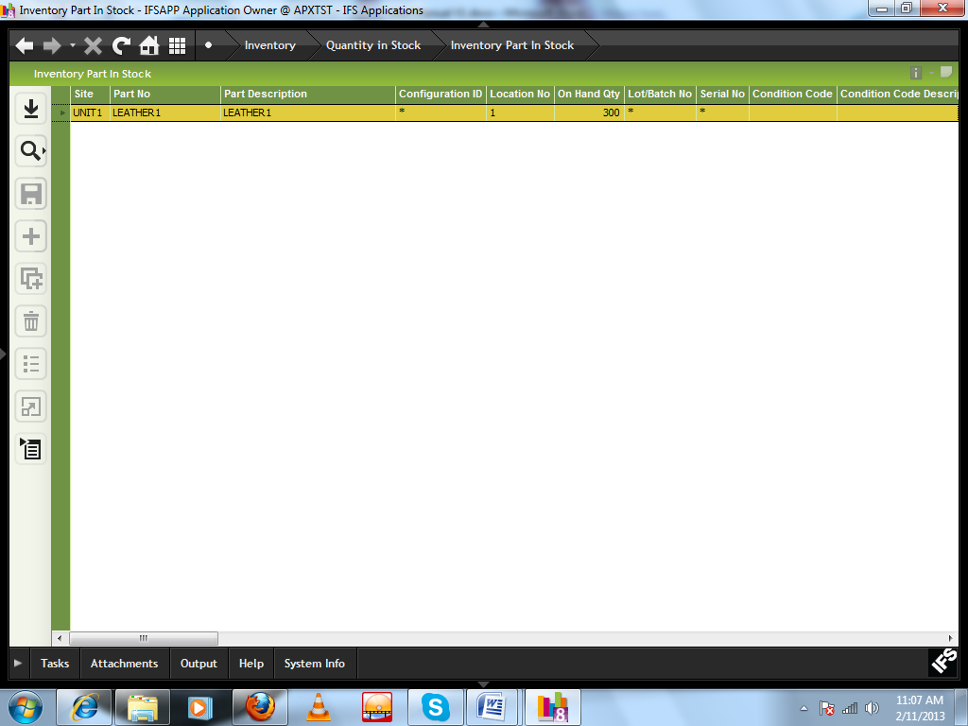

UNIT2
Manufacturing User Manual

In case of Unit 2 (leather production) all the process are same like UNIT1, except creation of Finished Goods Part no, creating Part catalog for FG and receiving Finished goods in inventory.

38) Creation Inventory Part (FG)
In case of UNIT2 we have to create Part ID for the respective article and also for all the sizes i.e. A Customer order has come of 100 pair (39/20,40/20,42/20,43/20.44/20) against an article WT75-02206E.
So you have to create six part id against this order for execution like
WT75-02206E
WT75-02206E-39
WT75-02206E-40
WT75-02206E-41
WT75-02206E-42
WT75-02206E-43

For planning and production execution we will use the part no WT75-02206E (without size part no) same as UNIT1.

39) Creating Part Catalog

For creating the Inventory part of FG while we are going to part catalog window, in case of UNIT2 we have to choose
Lot quantity Rule as “Many Lots Per Production Order”

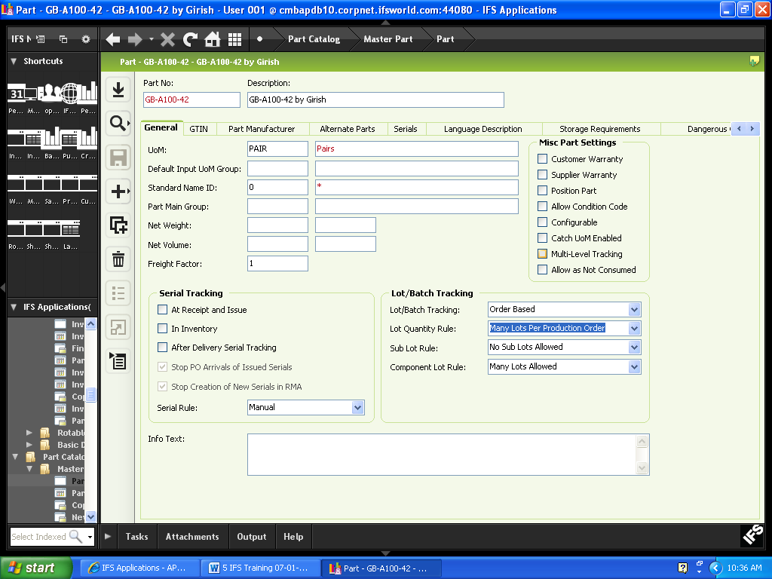

40) Receiving FG in Inventory
After production for receiving FG in inventory we have to click RMB on shop order window and select Receive and Click “Manual receive”
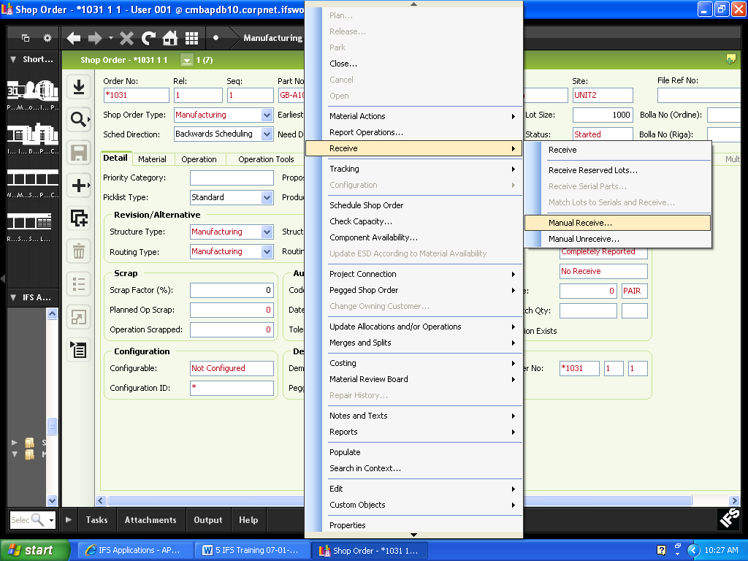
A new window will be appeared

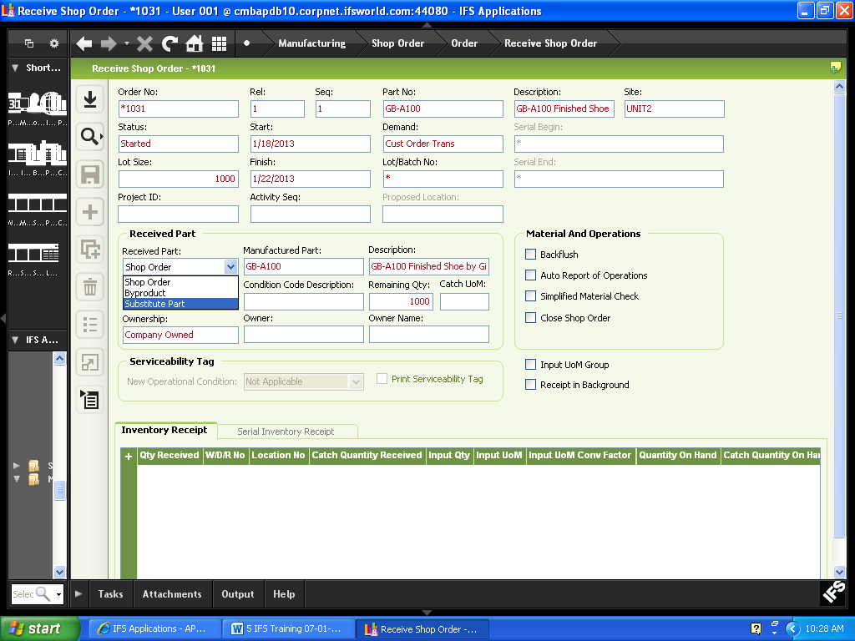
Receive Part: Select “Substitute Part” from the combo
Manufactured Part: Select from the LOV

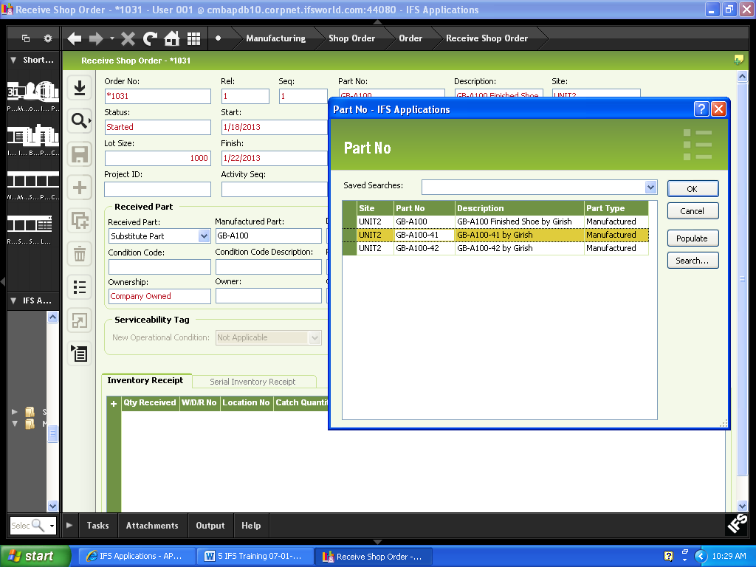
Click ‘+’ button to add new row
Qty Received: Enter the quantity
Location No: Enter the location no

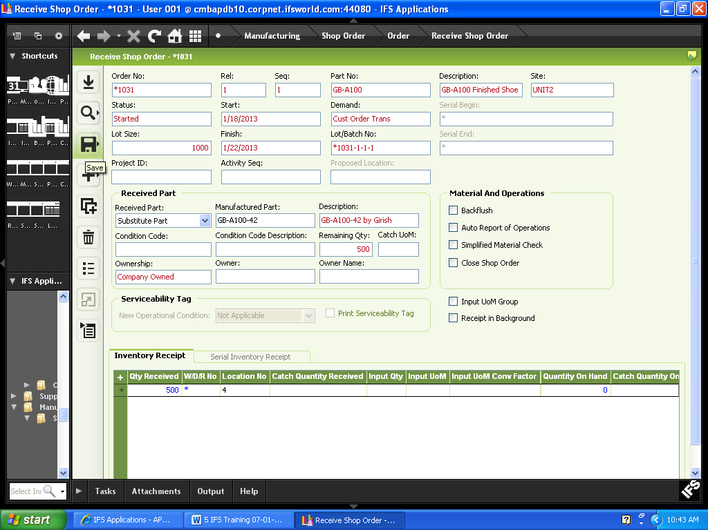
Click Save button

